Non-decontaminated analysis

Contents

Data structure 1

Blank samples 1

Relative Abundance 4

Phylum level 4

Class level 5

Family level 6

Across metamorphosis 7

Genus level 8

Across metamorphosis 9

Alpha Diversity 12

Beta Diversity 14

All samples combined 14

Hydropsychidae 14

Baetidae 14

Larval Hydropsychidae 15

Adult Tricoptera 18

Heptageniidae 19

Perlidae 20

Chironomidae 21

Araneidae 22

Differential Abundance 24

ACWA Stream comparisons 24

# Data structure

## Blank samples

1809 unique ASVs

Range from 16 – 63,500 counts

-The extraction reagent blanks from the first 4 plates are relatively low (16 - 629 counts)

-The extraction reagent blanks from the last plate (only 9 samples on it) is very high (44,645 and 57,629 counts)

-Buffer tube blanks were run on the last (contaminated) plate and have 56,500 and 63,500 counts

Phylum level structure (top 3):

-Firmicutes (42.3 %), Proteobacteria (19.6 %), Bacteroidota (13.4 %)

Class level structure (top 3):

-Clostridia (35.2 %), Bacteroidia (13.3 %), Alphaproteobacteria (10.1)

Order level structure (top 3):

-Lachnospirales (15.0 %), Oscillospirales (14.2 %), Burkholderiales (6.5 %)

Family level structure (top 3):

-Lachnospiraceae (14.9 %), Ruminococcaceae (6.9 %), Oscillospiraceae (5.5 %)

Genus level structure (top 3):

-Faecalibacterium (1.99%), Ruminococcus torques group (1.8 %), Blautia (1.6 %)

Species level structure (top 3):

-prausnitzii (1.0 %), bacterium (0.44%), hadrus (0.39%)

Total numbers of ASVs at each level:

Phylum: 26, Class: 57, Order: 136, Family: 199, Genus: 400.

Relative abundance

Class level:

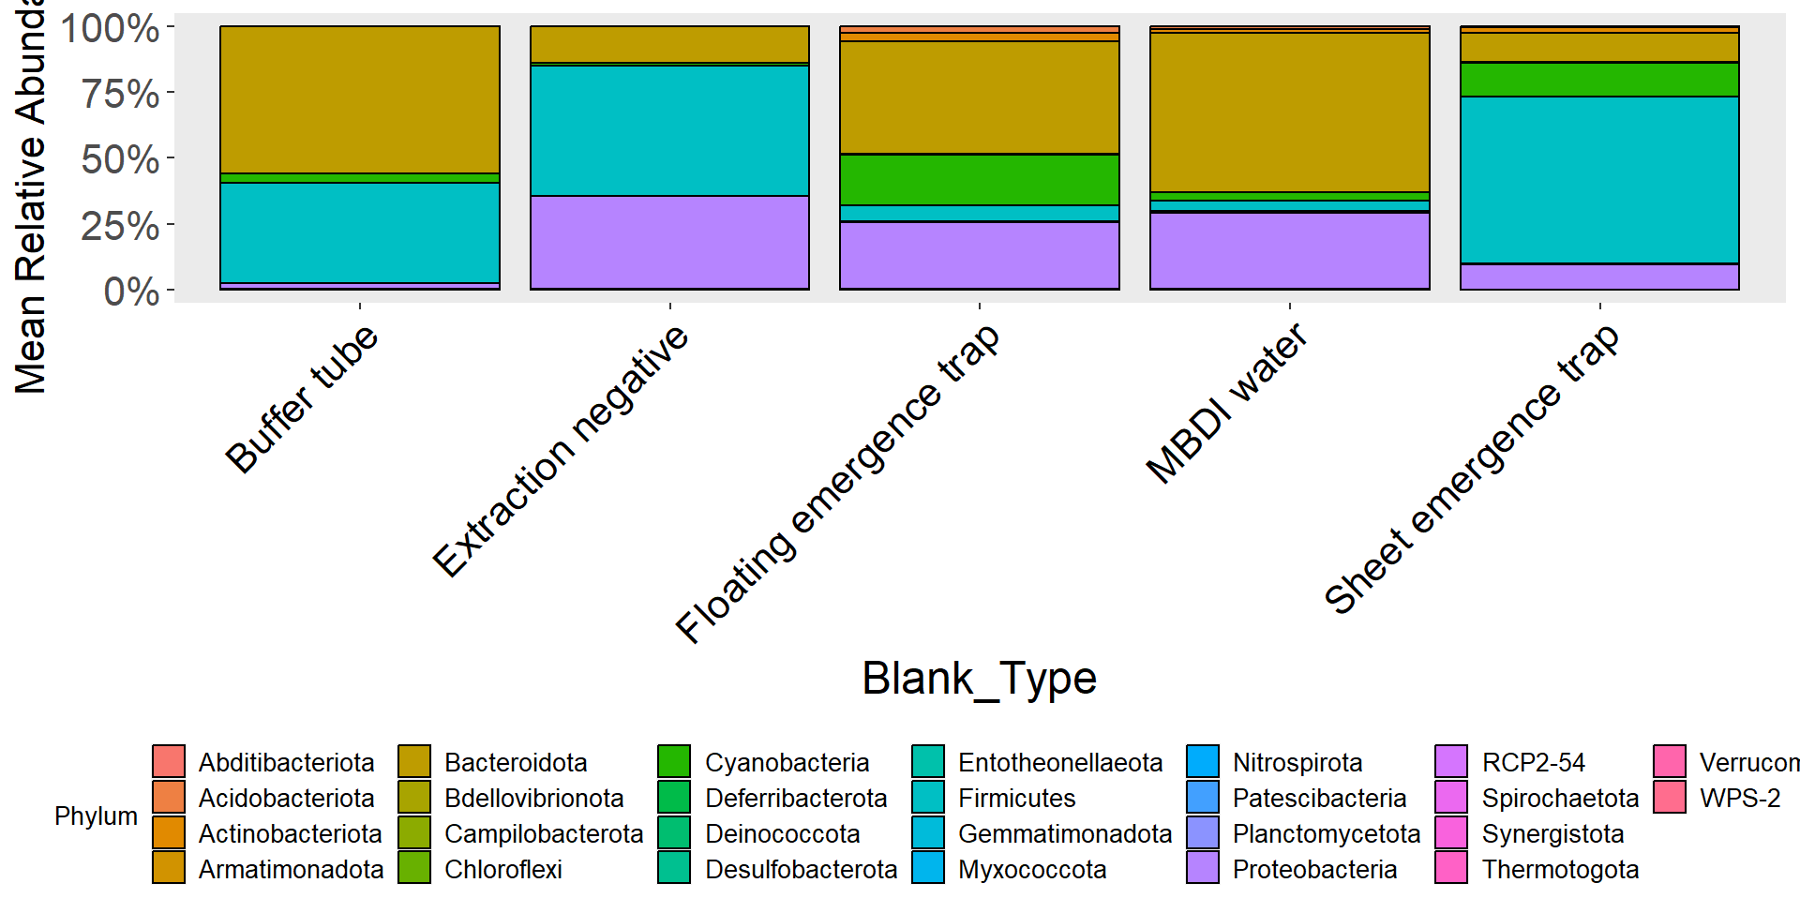

Figure 1: Mean relative abundance of bacterial phyla in laboratory and field blanks.

Family level:

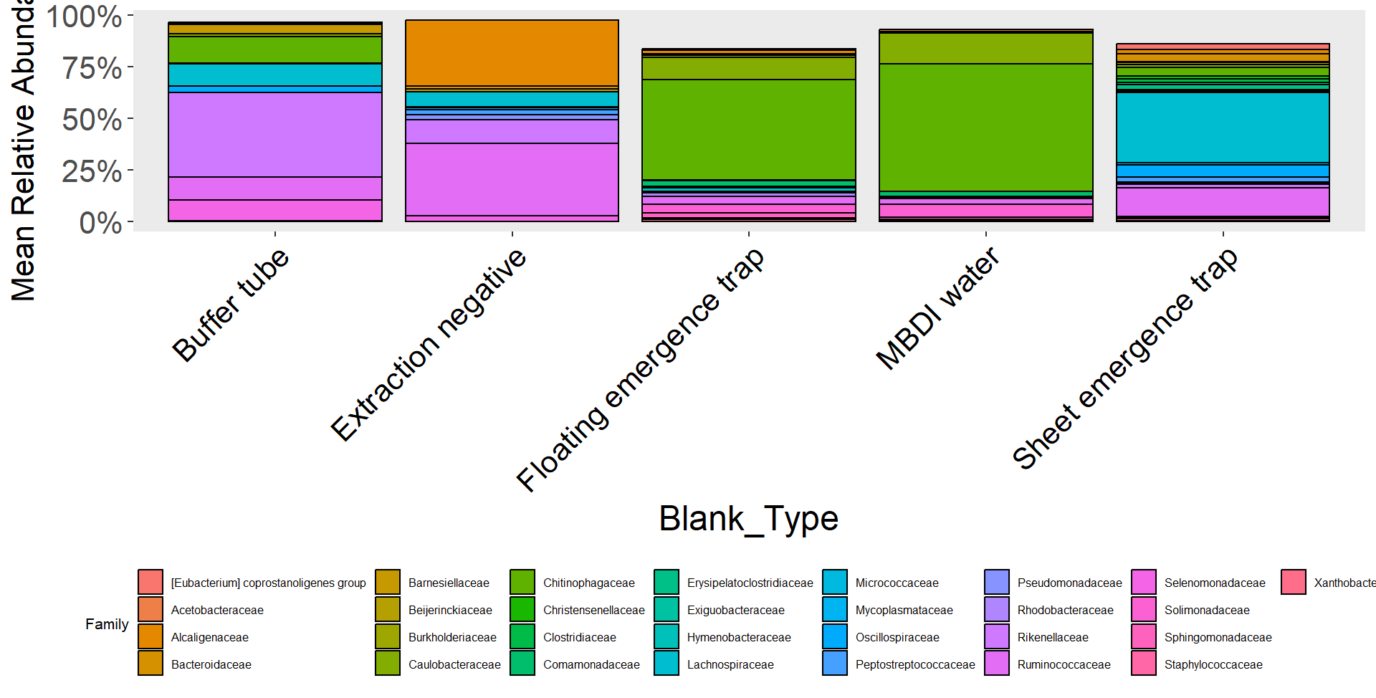

Figure 2: Mean relative abundance of bacterial families present in at least 5% of total ASVs in laboratory and field blanks.

Genus level:

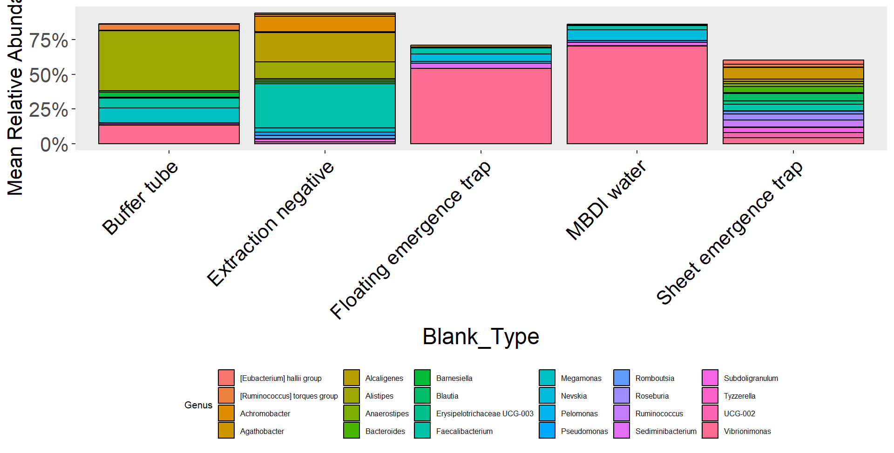

Figure 3: Mean relative abundance of bacterial genera present in at least 10% of all ASVs in laboratory and field blanks.

Floating emergence trap blank and MBDI water rinse are similar to each other and very distinct from the laboratory blanks and the sheet emergence blank.

# Relative Abundance

## Phylum level

Not decontaminated data:

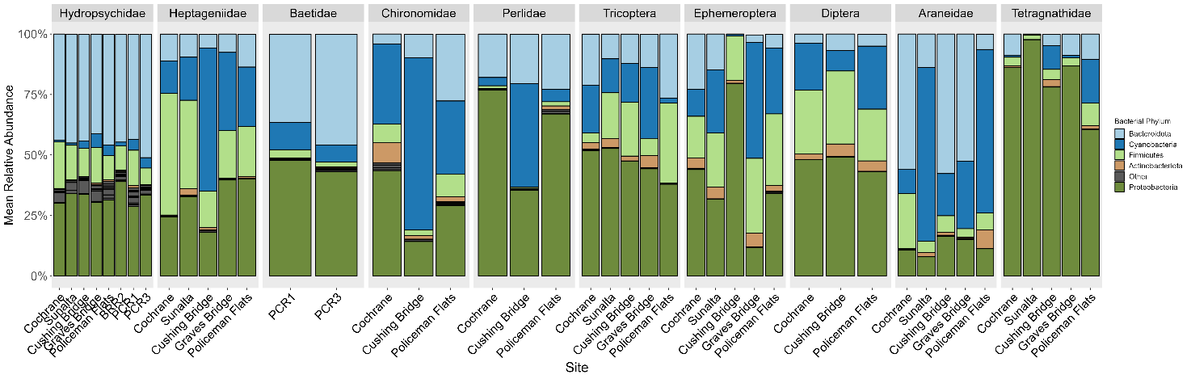

Figure 4: Mean relative abundance of the top 5 most abundant bacterial phyla present in all larvae, adults, and spider samples.

Decontaminated data:

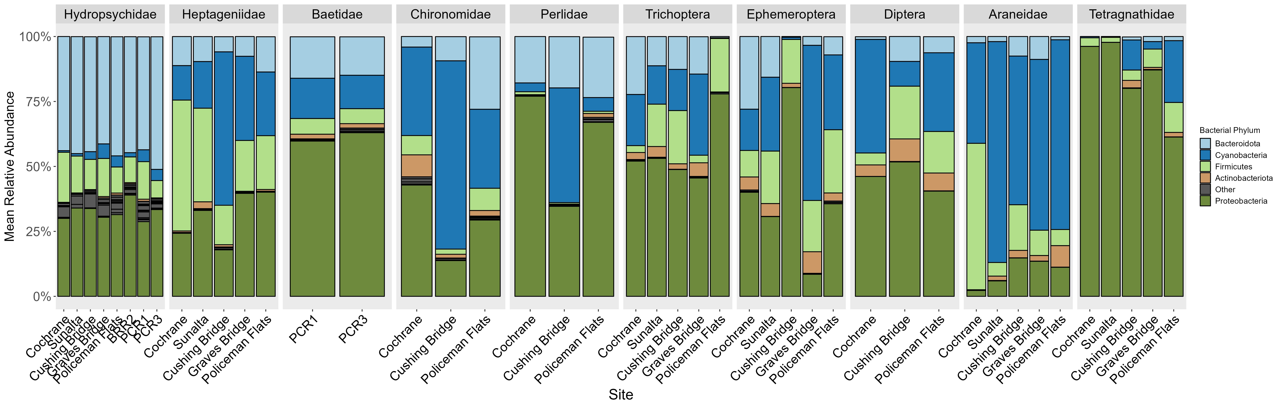

Figure 5: Mean relative abundance of the top 5 most abundant bacterial phyla present in all larvae, adults, and spider samples.

Some change in composition of Baetidae, adult tricoptera at Policeman Flats, and Araneidae between raw data and decontaminated data.

## Class level

Non decontaminated data:

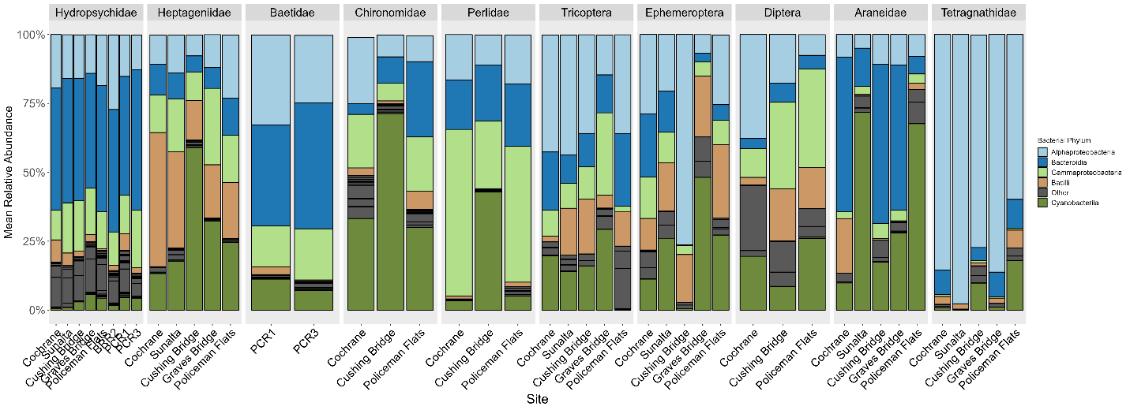

Figure 6: Mean relative abundance of the top 5 most abundant bacterial classes organized by larvae, adults, and spiders across collection sites.

Decontaminated data:

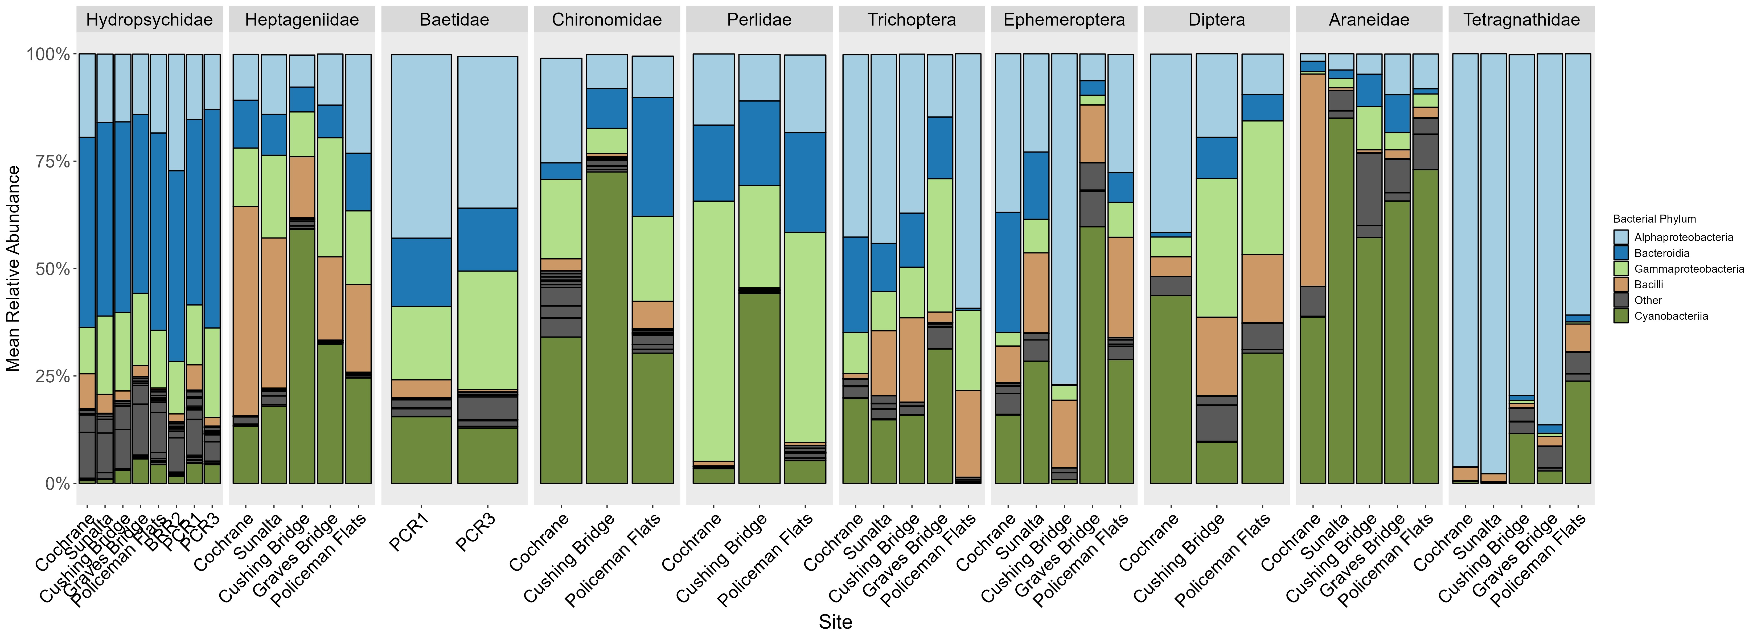

Figure 7: Mean relative abundance of the top 5 most abundant bacterial classes organized by larvae, adults, and spiders across collection sites.

Some change in composition of Baetidae, adult tricoptera at Policeman Flats, and Araneidae between raw data and decontaminated data.

## Family level

Non decontaminated data:

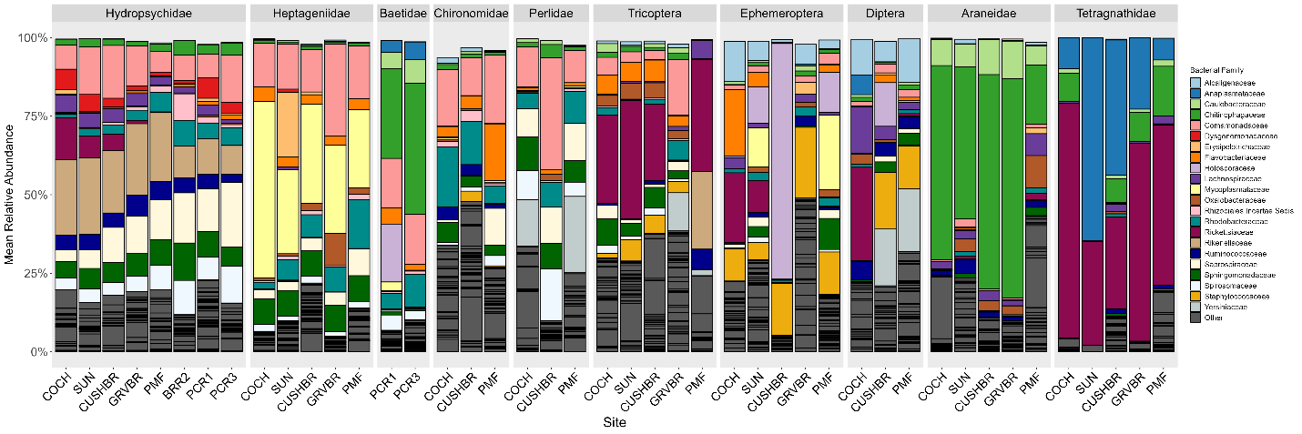

Figure 8: Mean relative abundance of top 22 bacterial families across invertebrate family and orders at each collection site.

Decontaminated data:

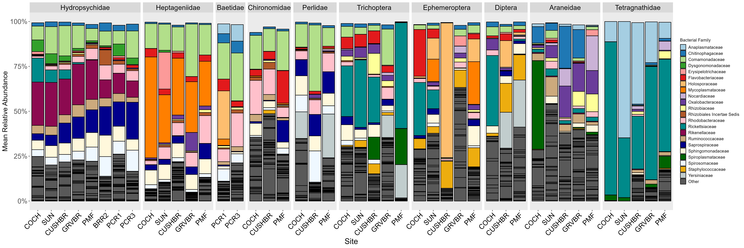

Figure 9: Mean relative abundance of top 22 bacterial families across invertebrate family and orders at each collection site.

Araneidae, Tetragnathidae, and Baetidae are different between raw data versus decontaminated data (especially Araneidae). Note that the colours don’t match between graphs.

### Across metamorphosis

Non decontaminated data:

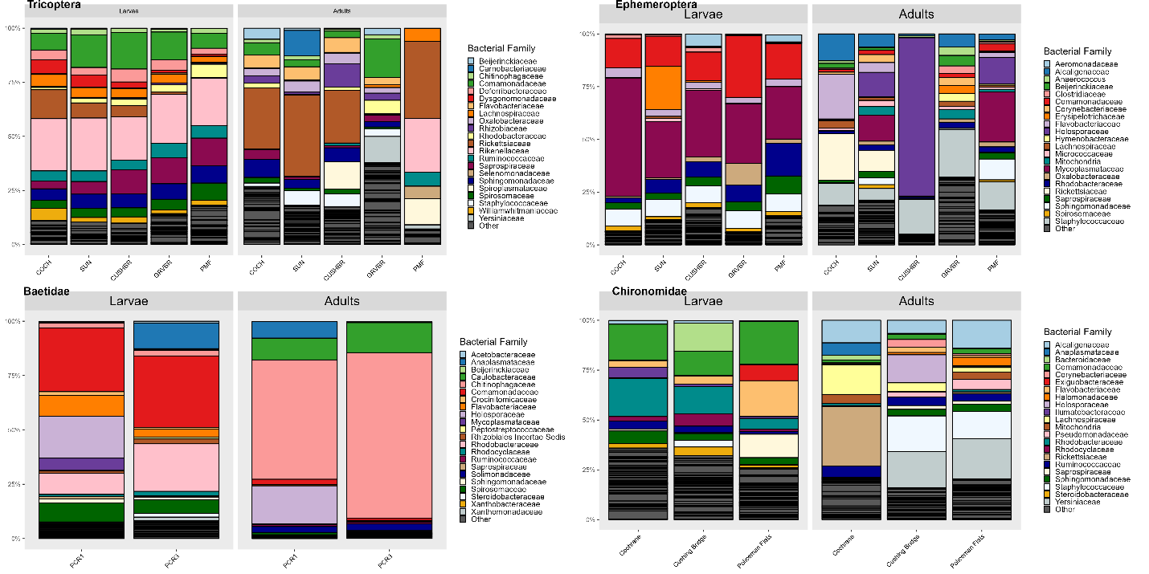

Figure 10: Mean relative abundance of bacterial families across invertebrate taxa metamorphosis (from larvae to adult) and sites.

Decontaminated data:

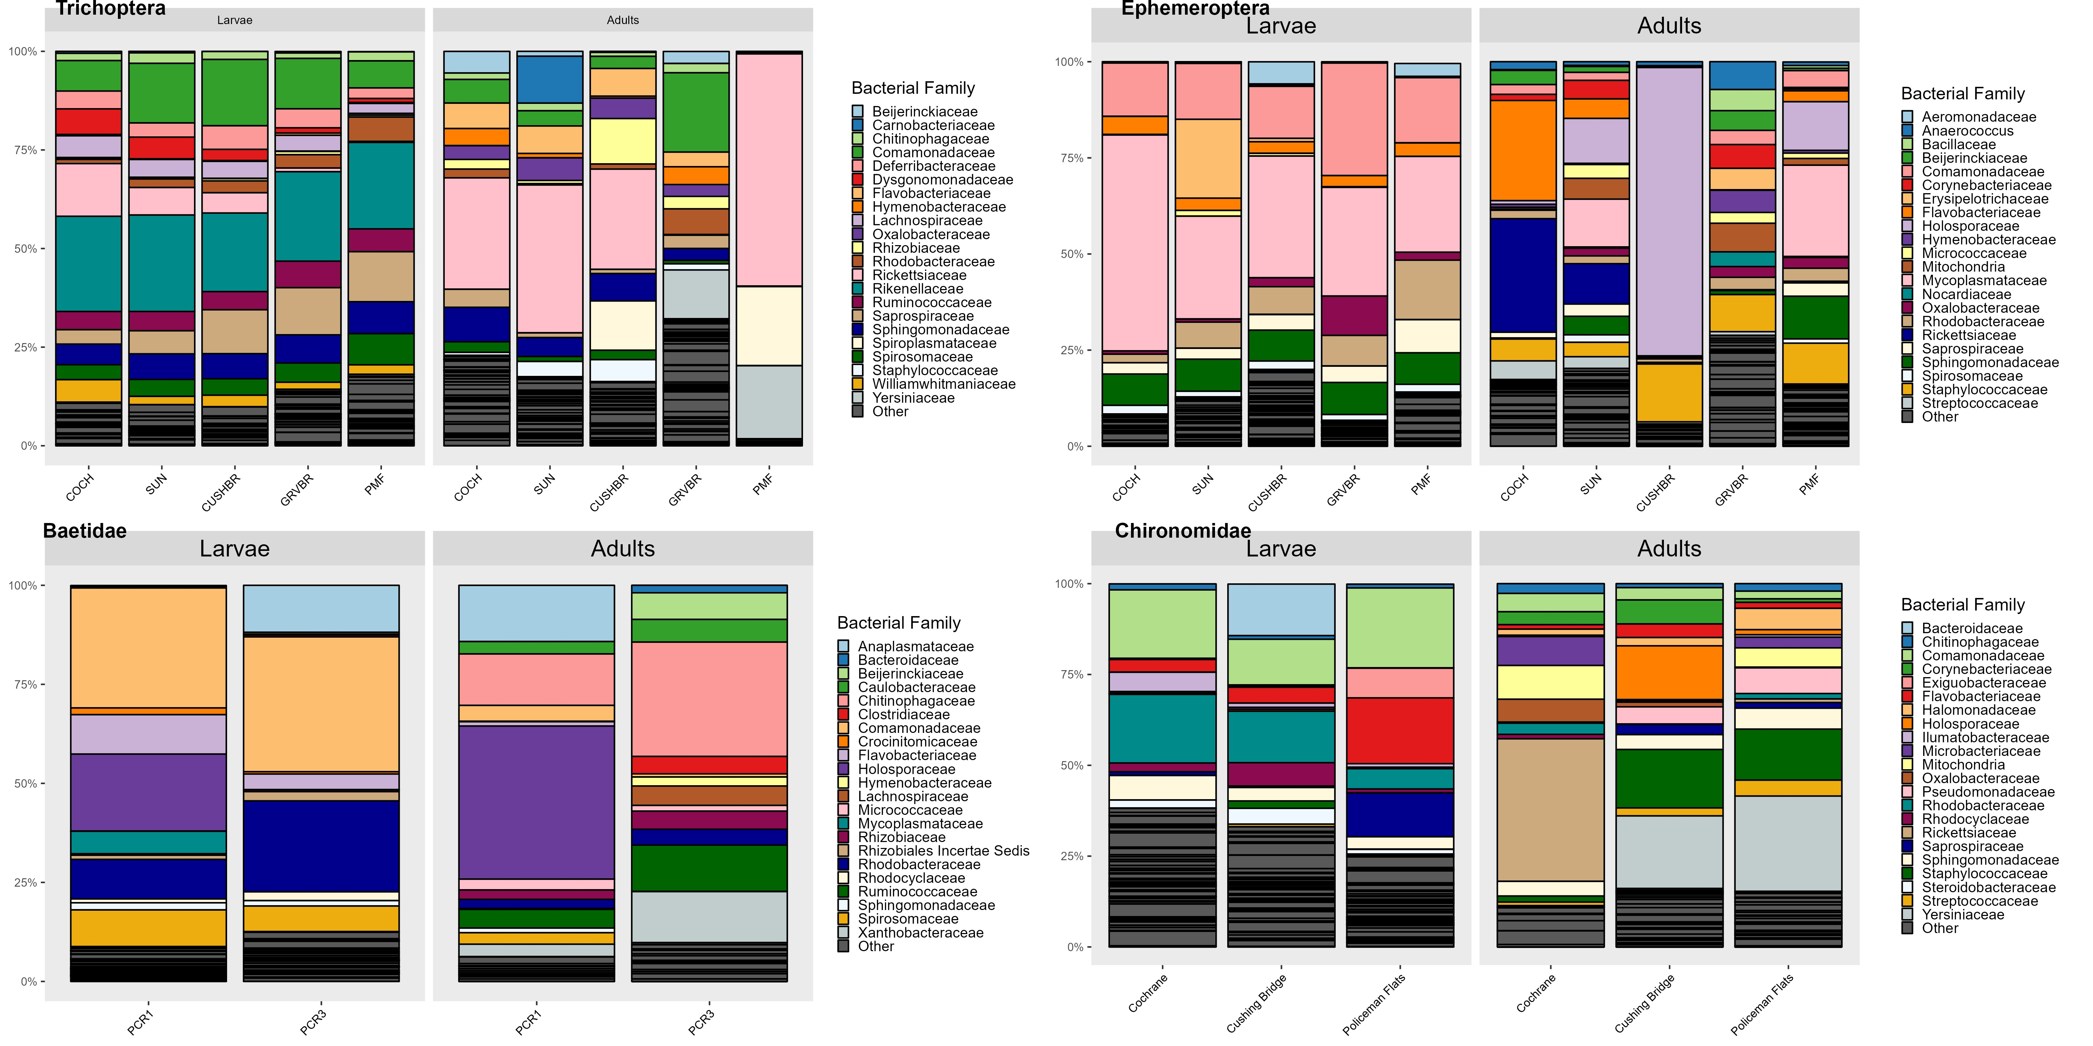

Figure 11: Mean relative abundance of bacterial families across invertebrate taxa metamorphosis (from larvae to adult) and sites.

Hydropsychidae are relatively unaffected by decontamination except adults at Policeman Flats (they were the ones that were on the plate with the contaminated extraction reagents).

Ephemeroptera (excluding Baetidae are unaffected).

Adult Baetids are different before and after decontamination. Larval baetids are unaffected.

Larval and adult chironomids are relatively unaffected.

## Genus level

Non decontaminated data:

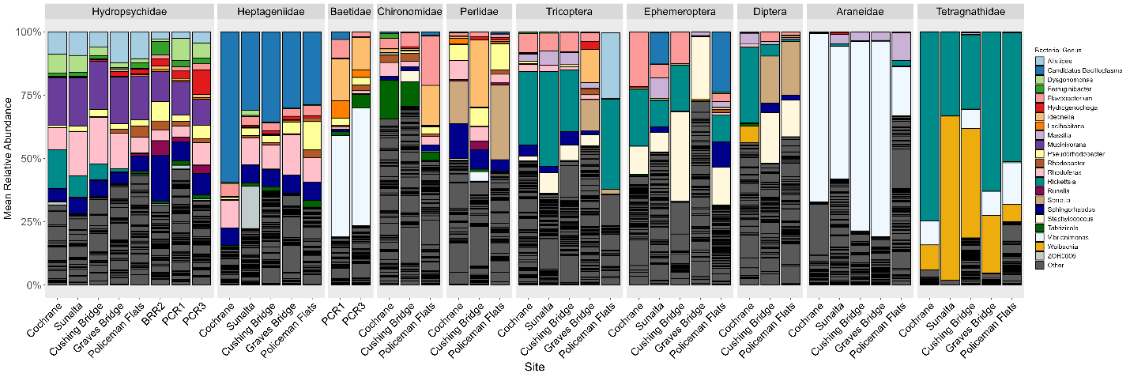

Figure 12: Mean relative abundance of top 22 bacterial genera across invertebrate taxa and collection sites.

Decontaminated data:

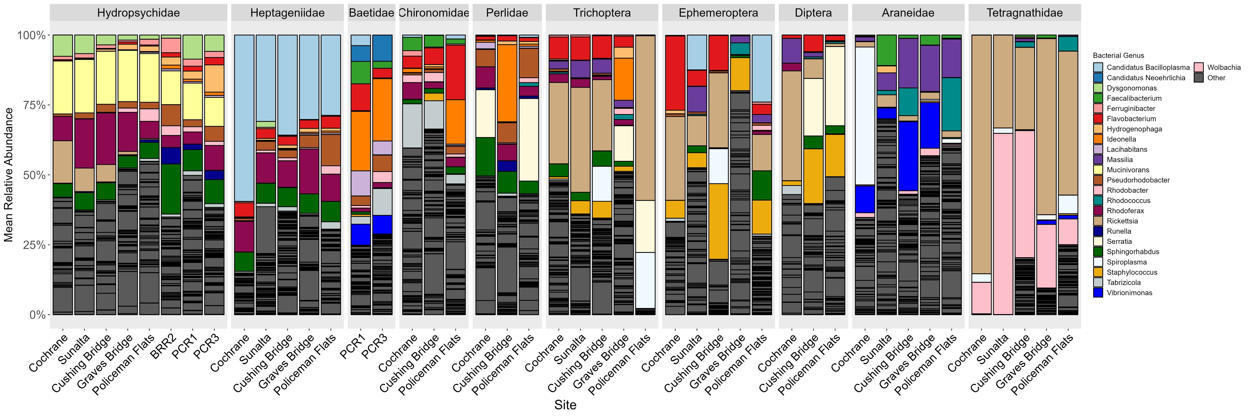

Figure 13: Mean relative abundance of top 23 bacterial genera across invertebrate taxa and collection sites.

### Across metamorphosis

Non decontaminated analysis:

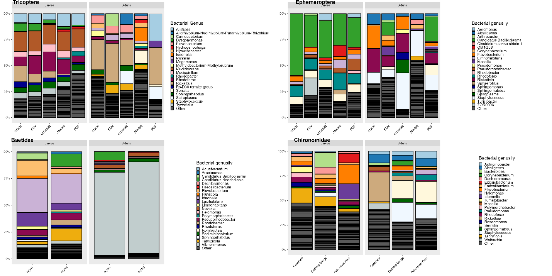

Figure 14: Mean relative abundance of bacterial genera across metamorphosis (larvae to adults) and sites.

Decontaminated analysis:

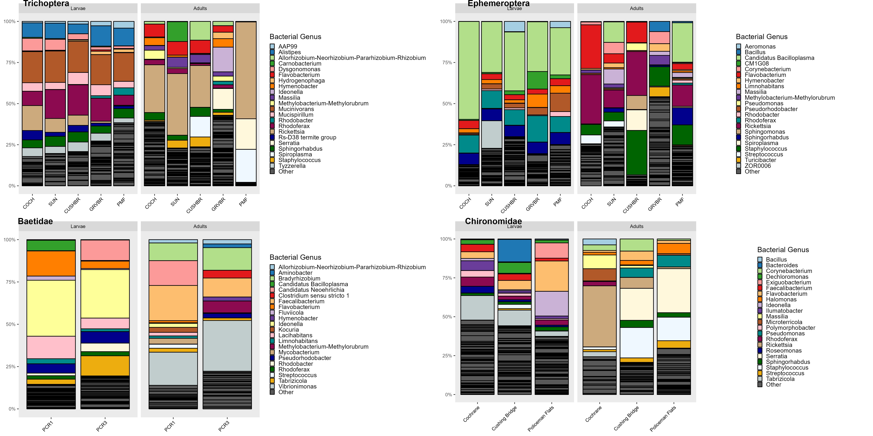

Figure 15: Mean relative abundance of bacterial genera across metamorphosis (larvae to adults) and sites.

Adult Baetids have a high amount of Vibriomonas in the non decontaminated data. Vibriomonas was also found at high levels in the floating emergence trap and ultrapure water blanks. Could be coming from contamination or maybe just high in the ACWA streams?

Seems like Vibriomonas is the most abundant “contaminant” (found both in insects and in field blanks). It is commonly found in lake/freshwater systems so maybe it isn’t contamination, it might just be very prevalent…

# Alpha Diversity

Non decontaminated analysis: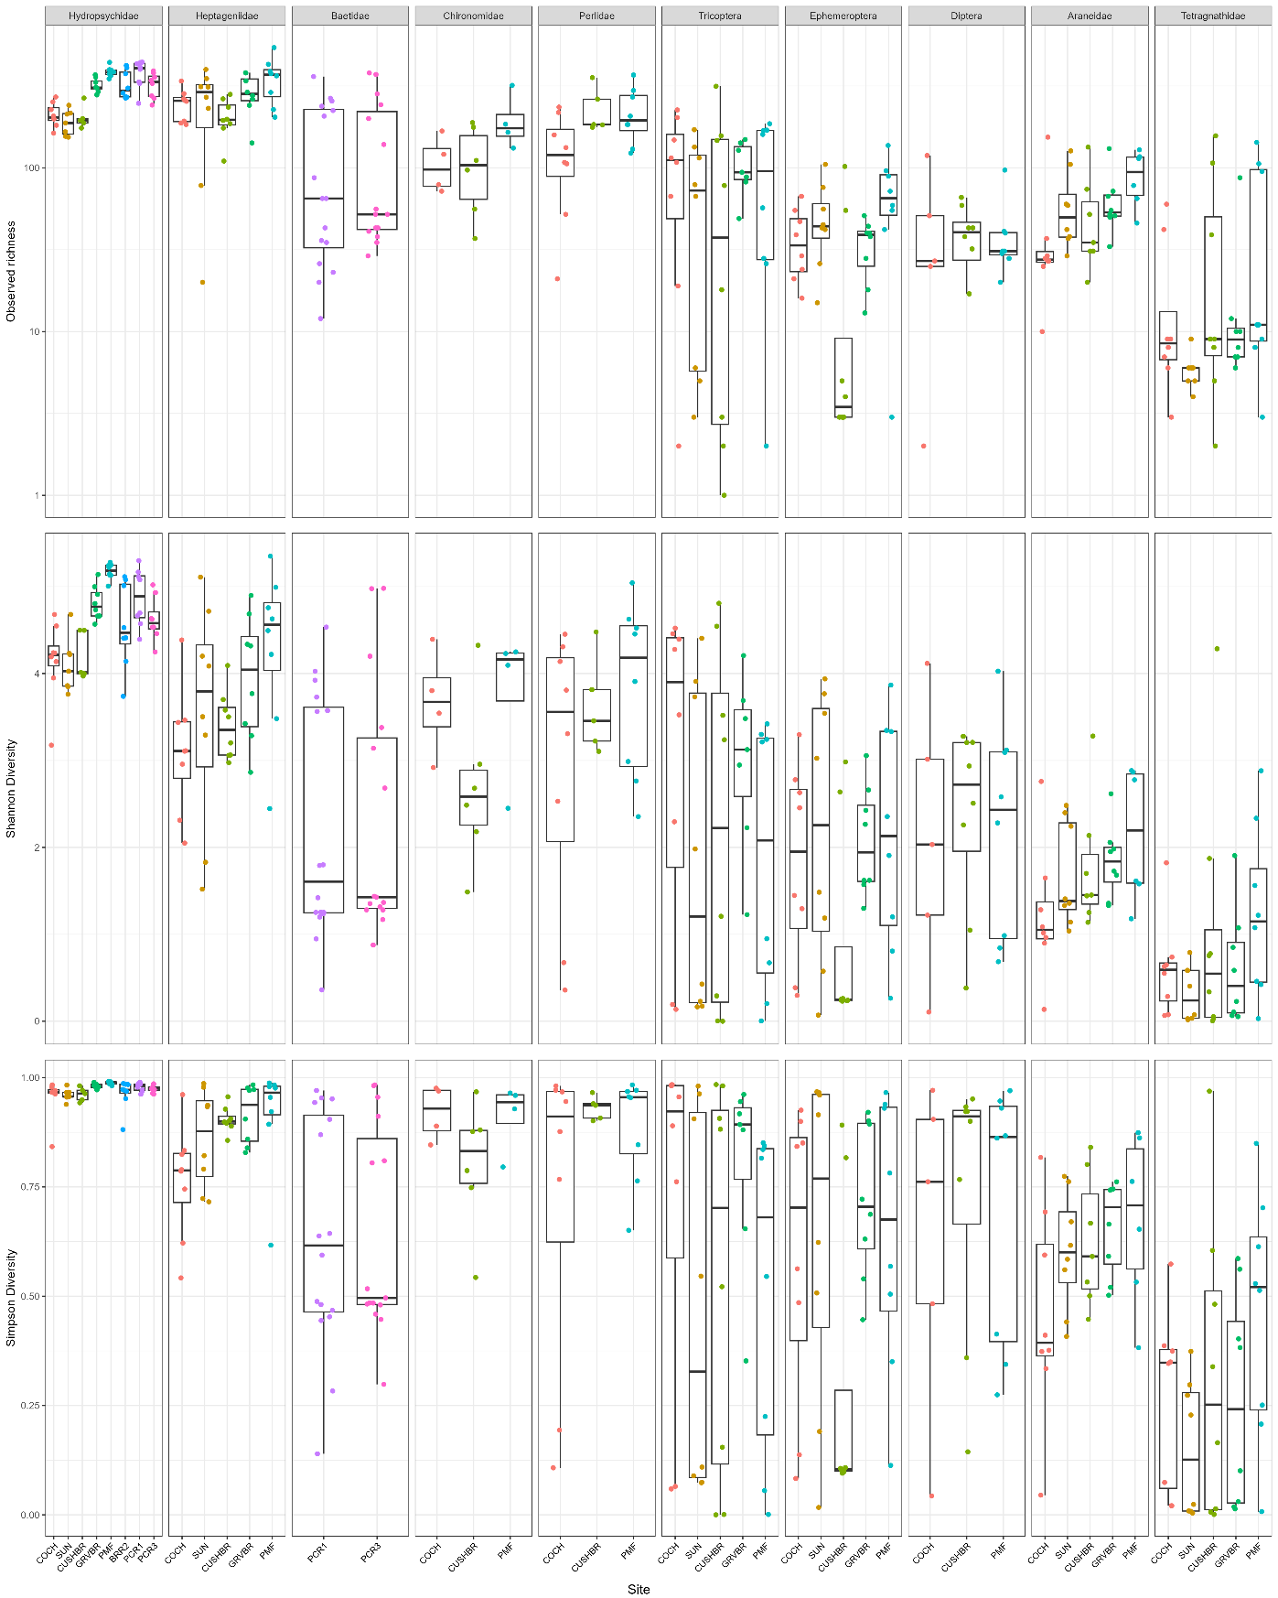

Decontaminated analysis:

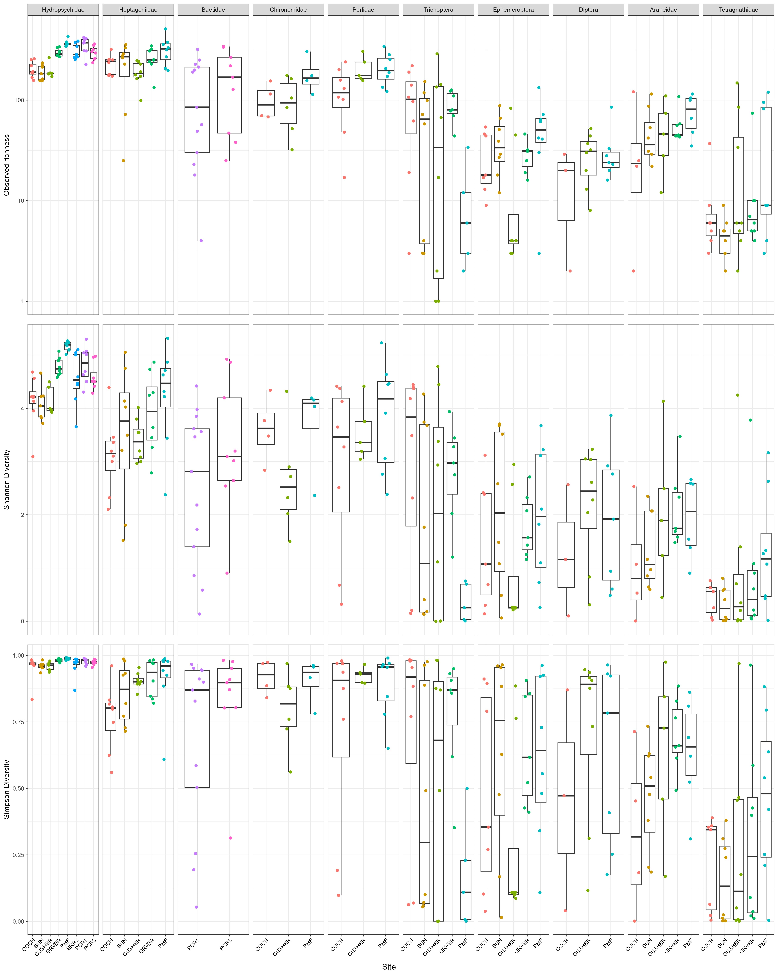

# Beta Diversity

## All samples combined

Bow and ACWA sites:

Non decontaminated analysis:

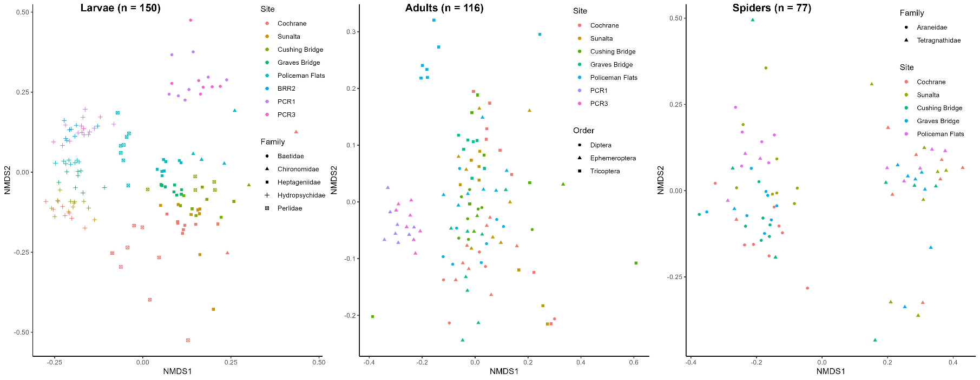

## Hydropsychidae

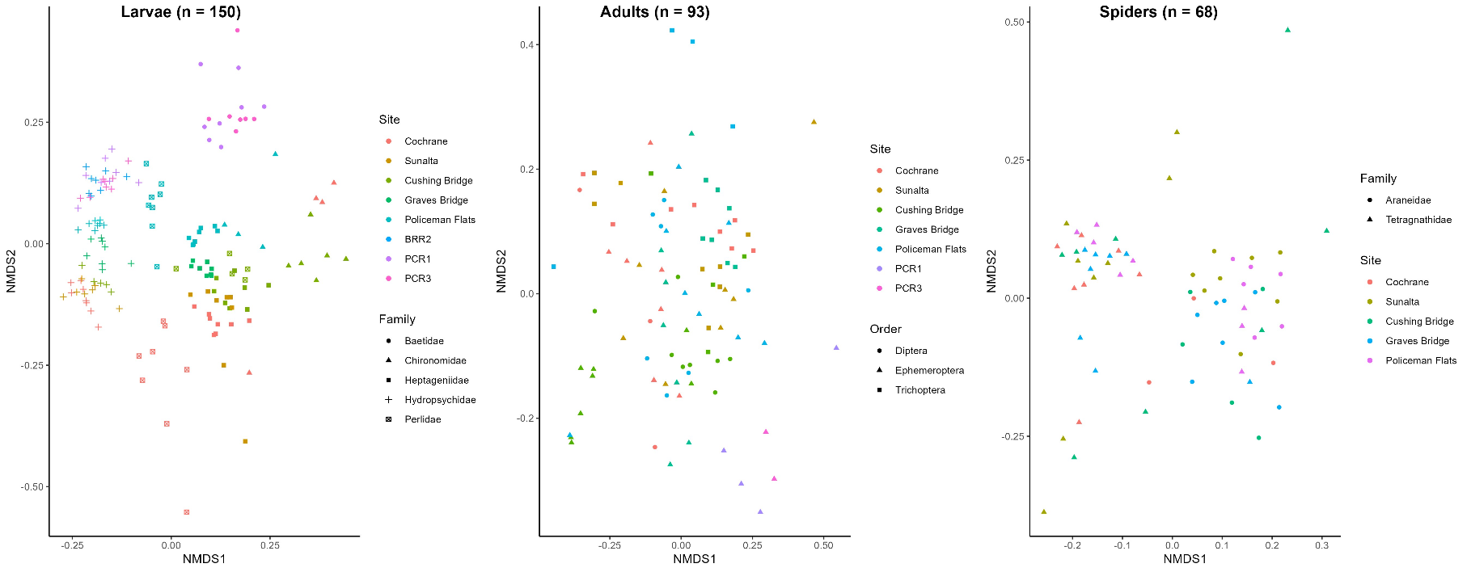Decontaminated analysis:

## Baetidae

Non decontaminated analysis:

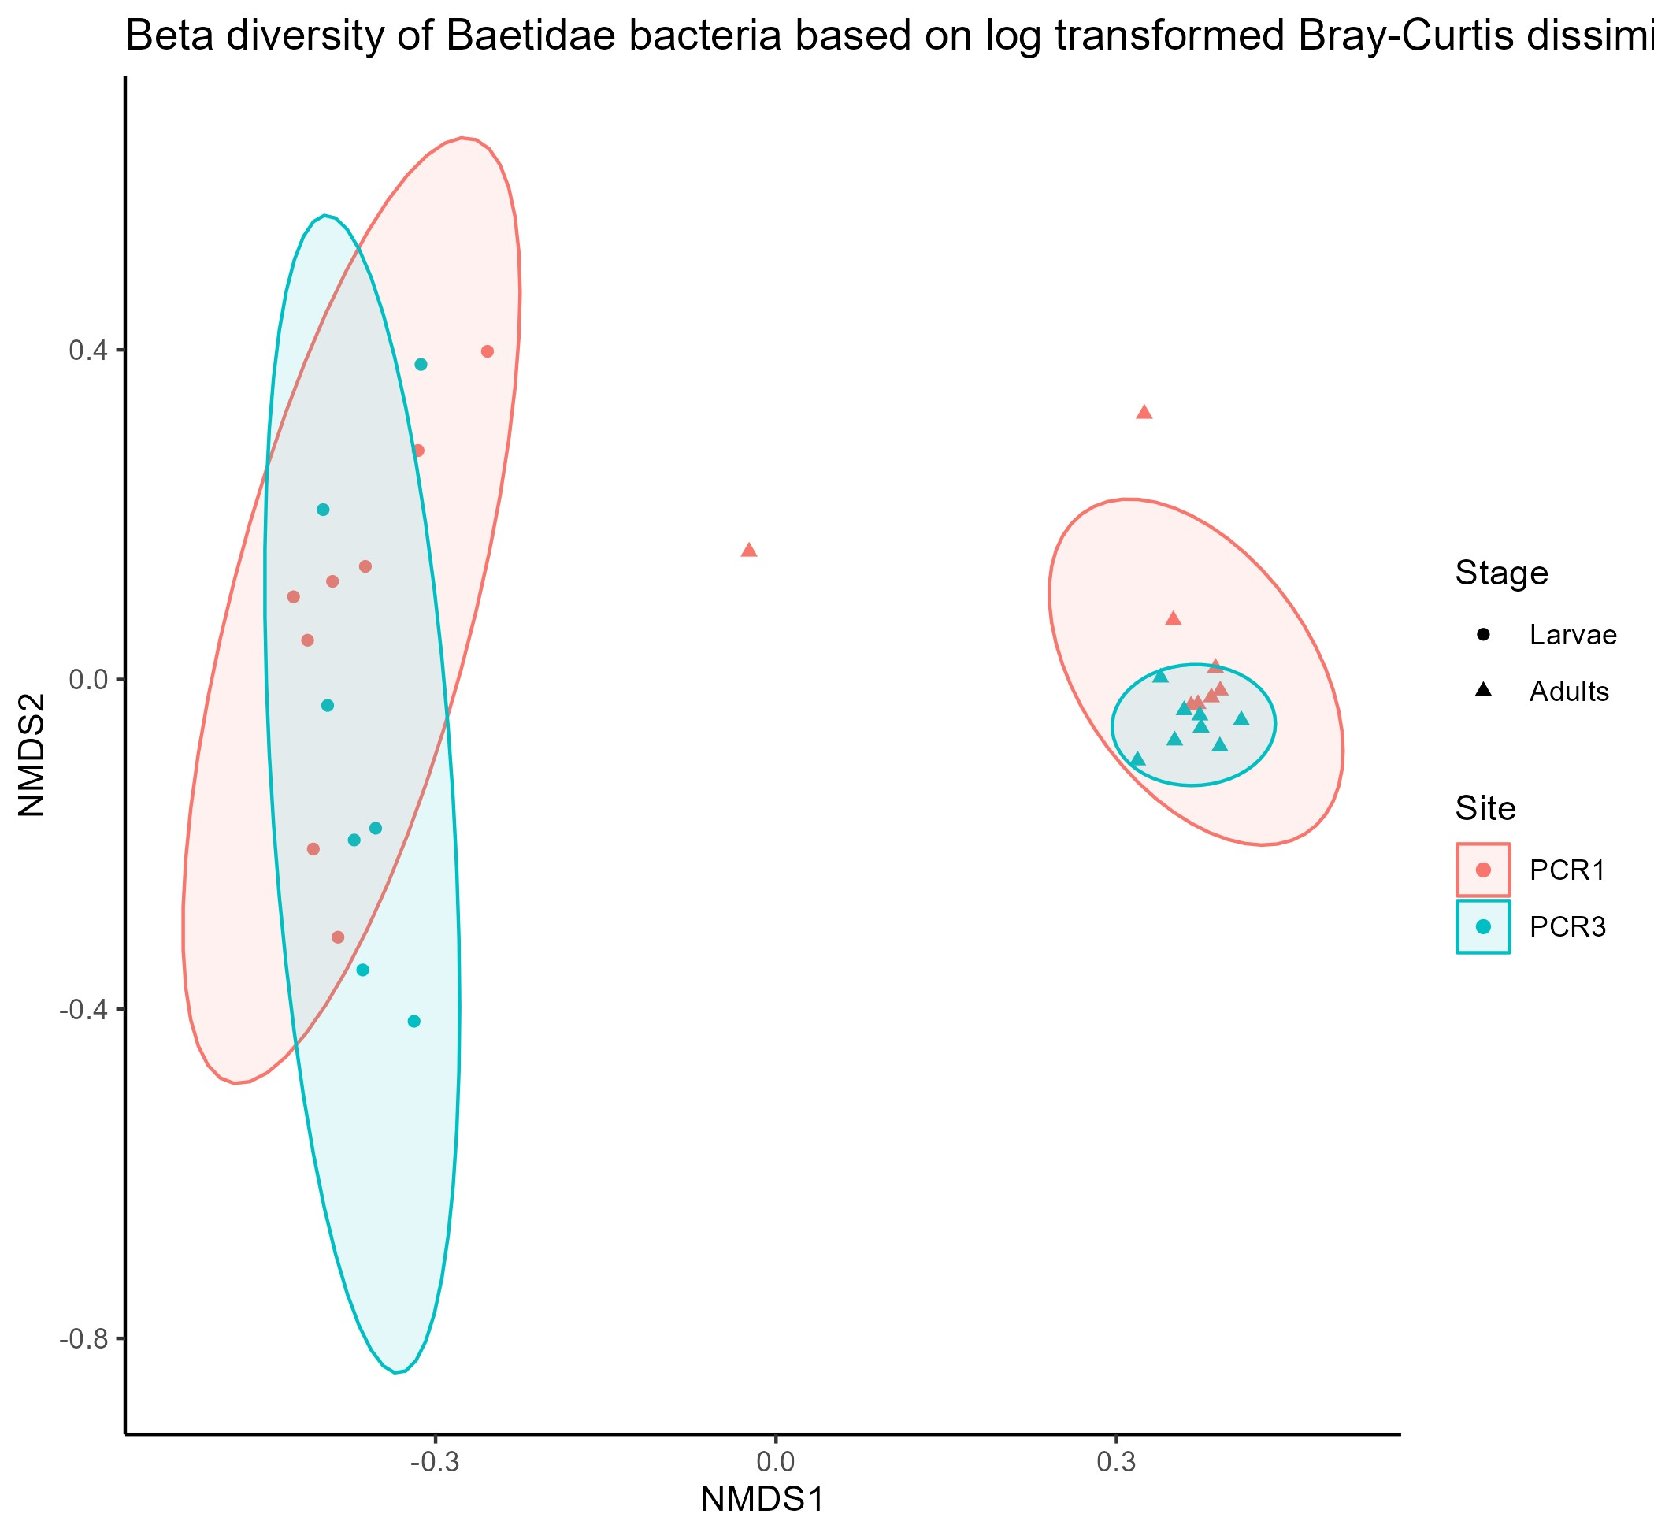

No difference between PCR1 – PCR3. Sig. difference between larvae and adults. No sig. beta dispersion.

Decontaminated analysis:

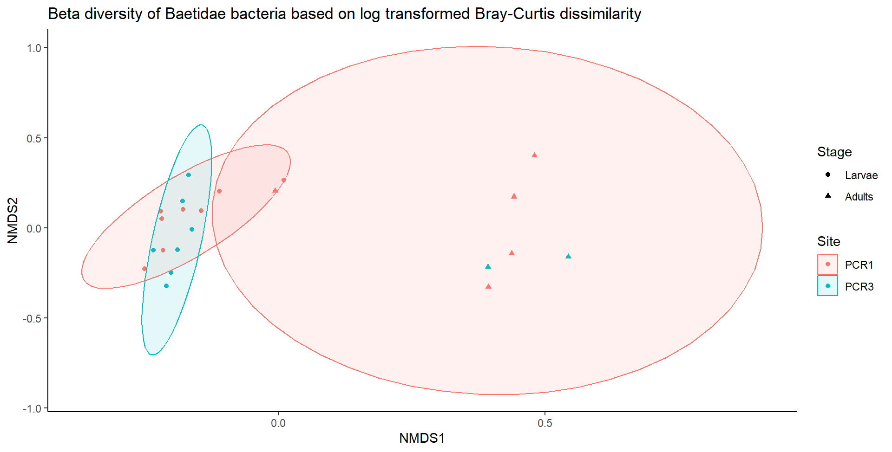

No difference between PCR1 – PCR3. Sig. difference between larvae and adults. No sig. beta dispersion.

## Larval Hydropsychidae

Non decontaminated analysis:

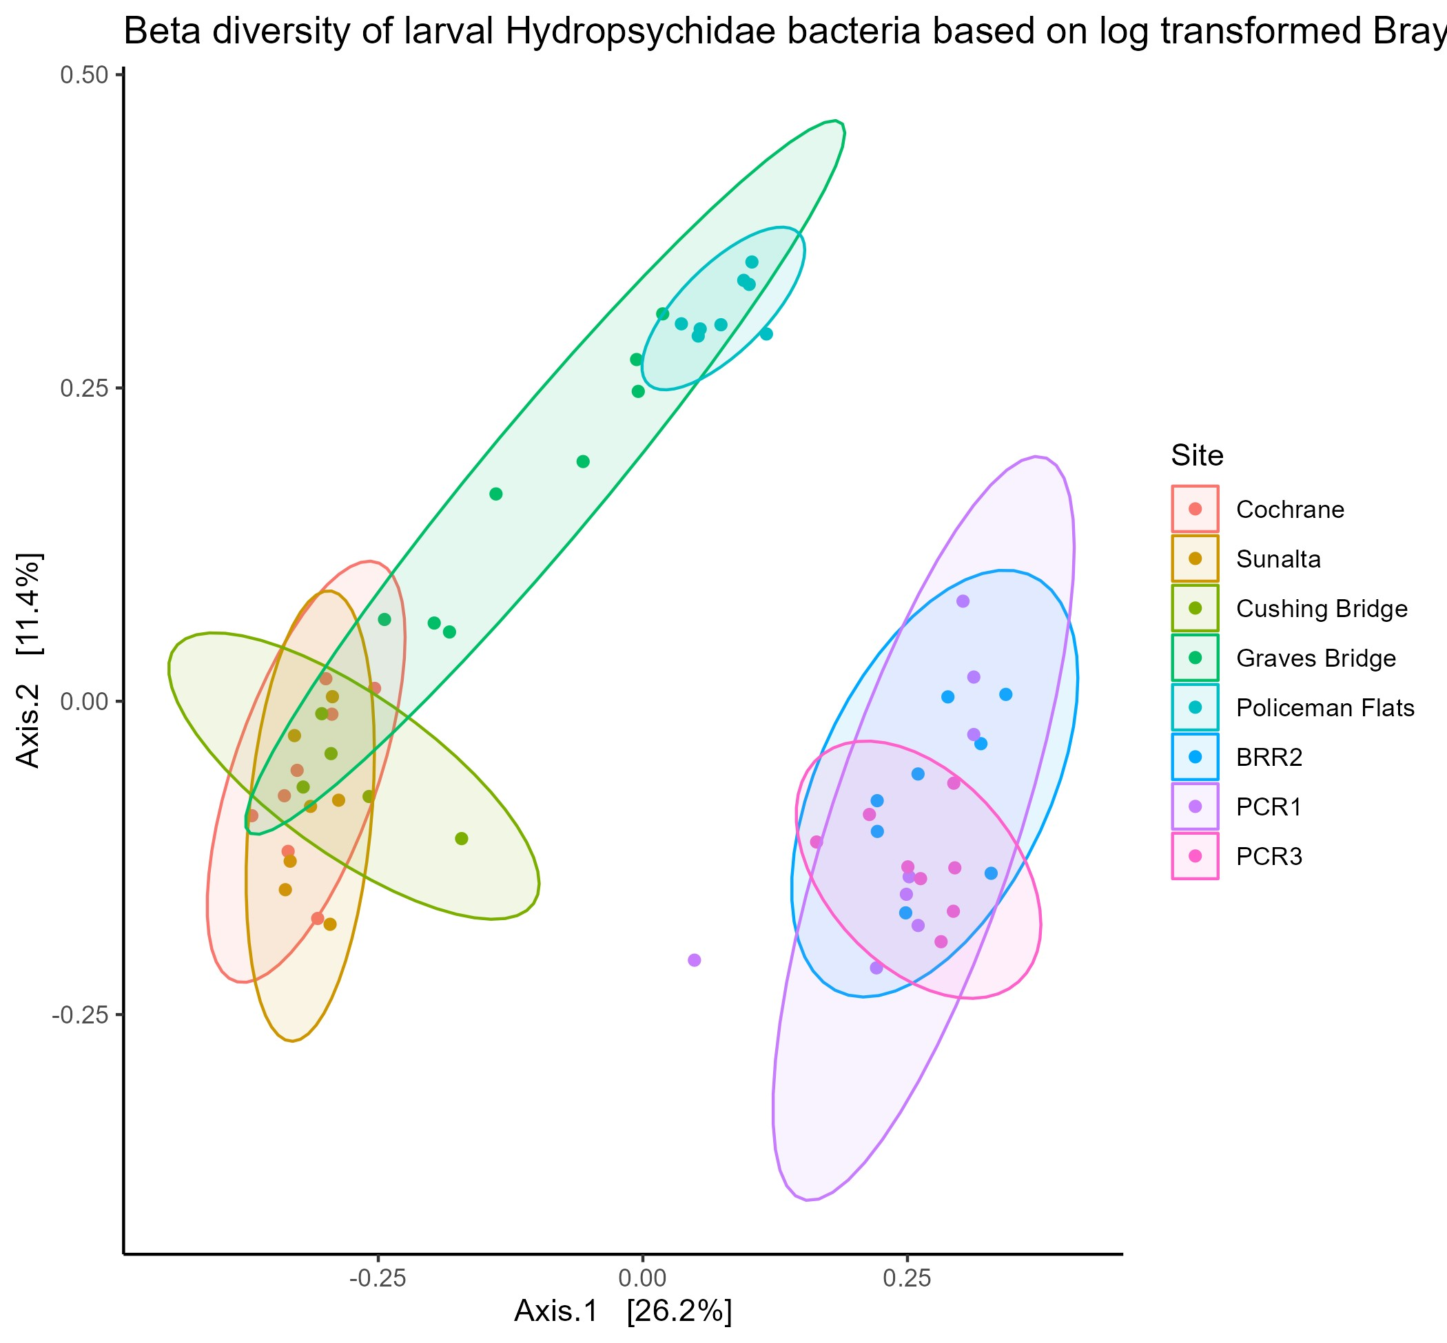

Only non-significant comparison is between Cushing Bridge and Sunalta. Beta dispersion was significant.

Decontaminated analysis:

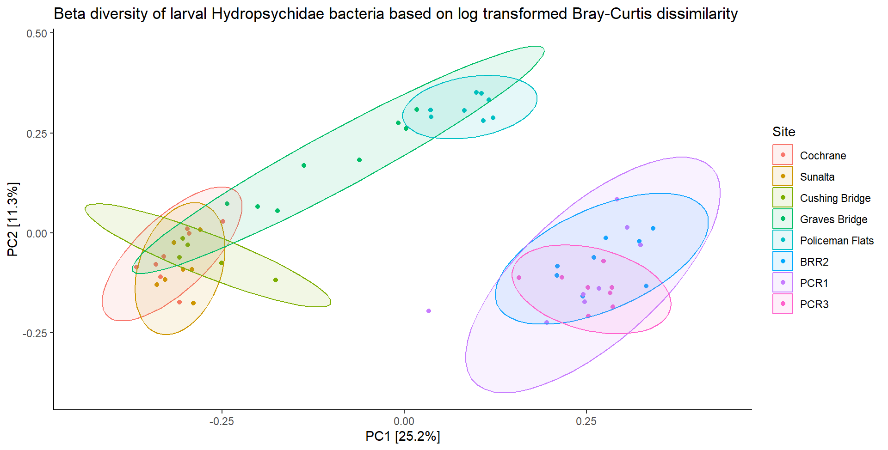

Only non-significant comparison is between Cushing Bridge and Sunalta. Beta dispersion was significant.

Bow River sites only

Non decontaminated analysis:

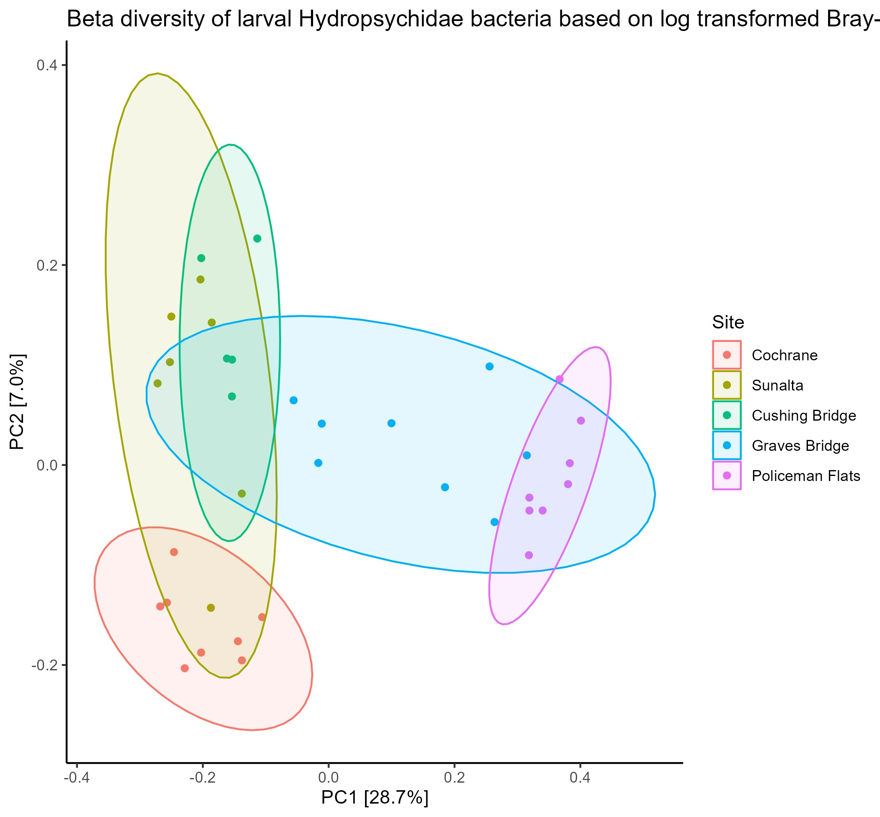

Only non-significant comparison is between Cushing Bridge and Sunalta. Beta dispersion was significant.

Decontaminated analysis:

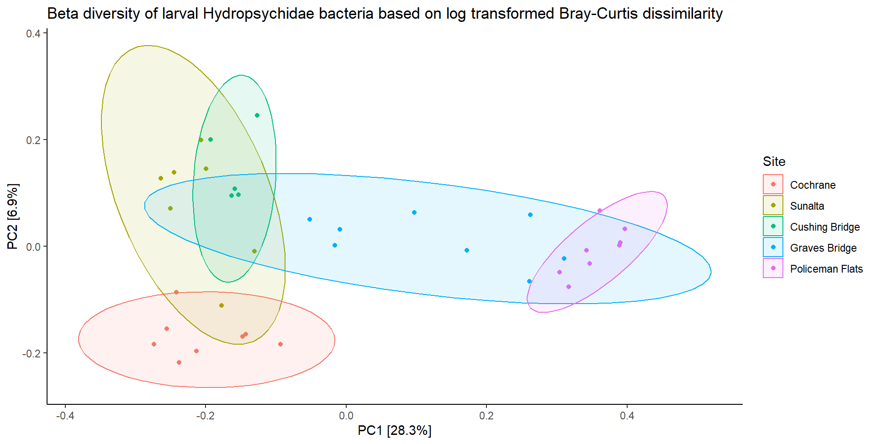

Only non-significant comparison is between Cushing Bridge and Sunalta. Beta dispersion was significant.

ACWA sites only

Non decontaminated analysis:

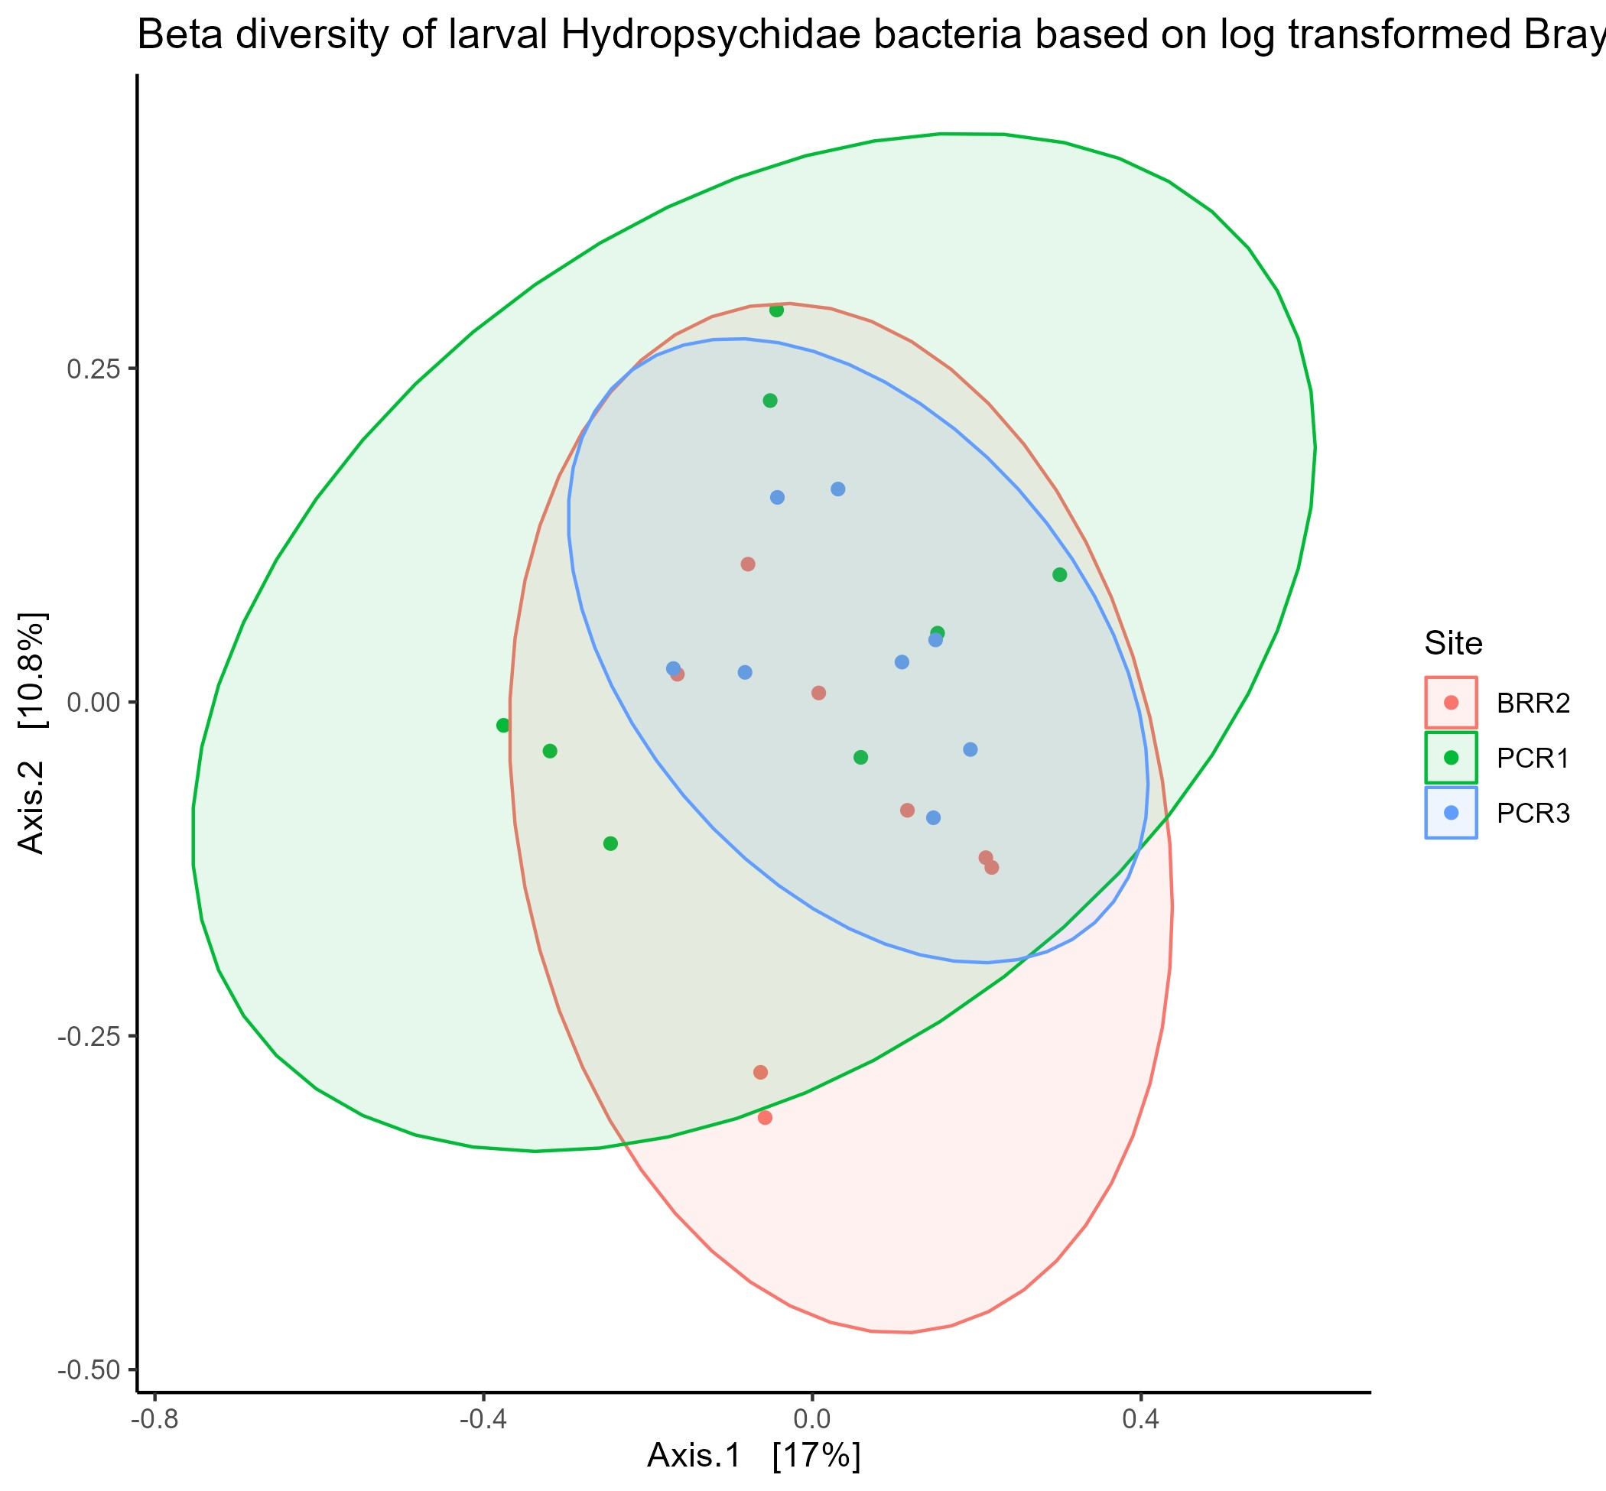

Significant differences between BRR2 – PCR3 and BRR2 - PCR1 but not between PCR1-PCR3.

Decontaminated analysis:

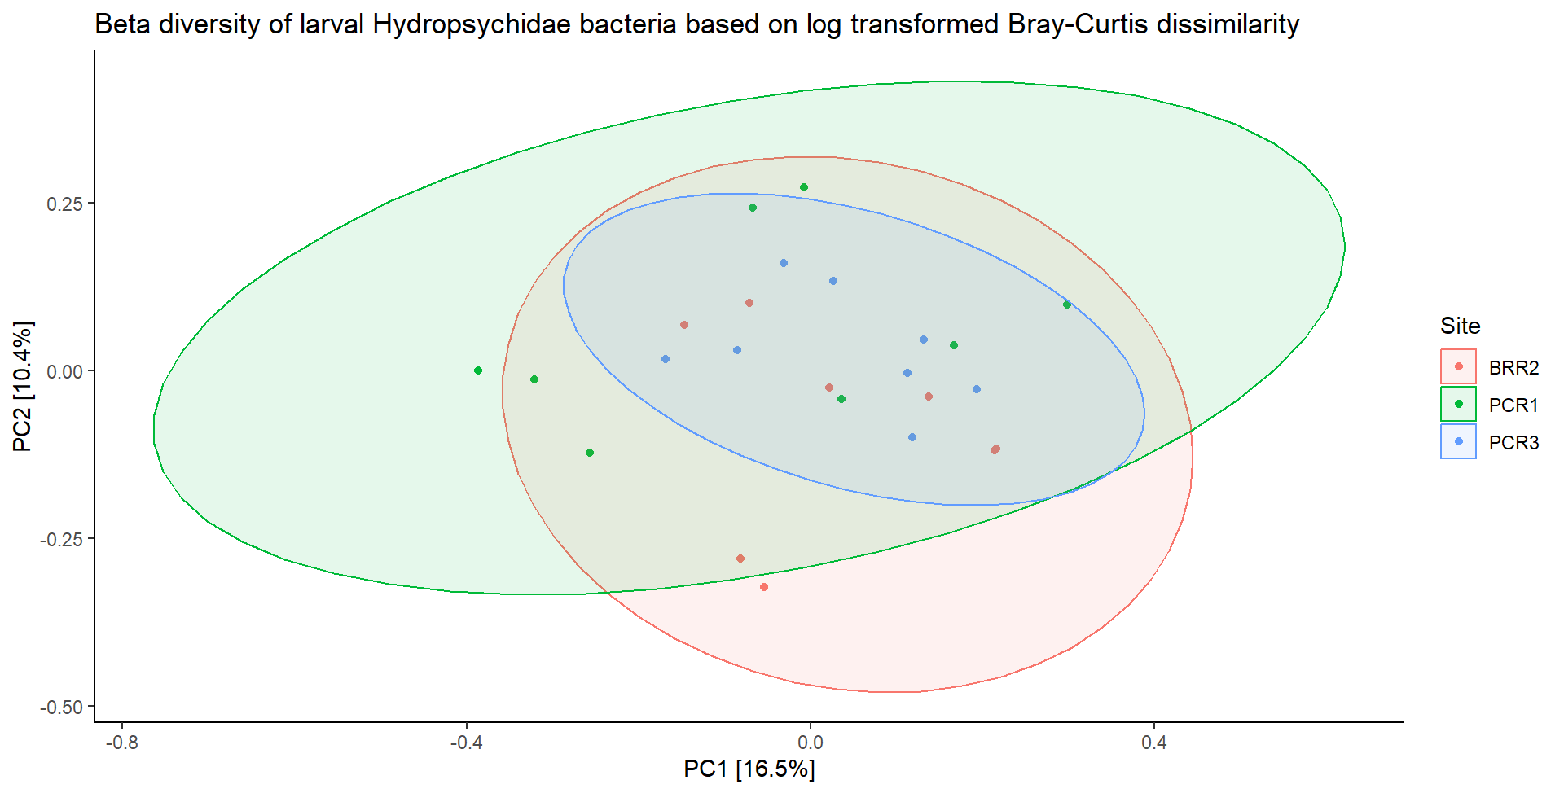

Sig. diff between all sites (p=0.002). All pairwise comparisons were significant. Beta dispersion was not significant.

## Adult Tricoptera

Non decontaminated analysis:

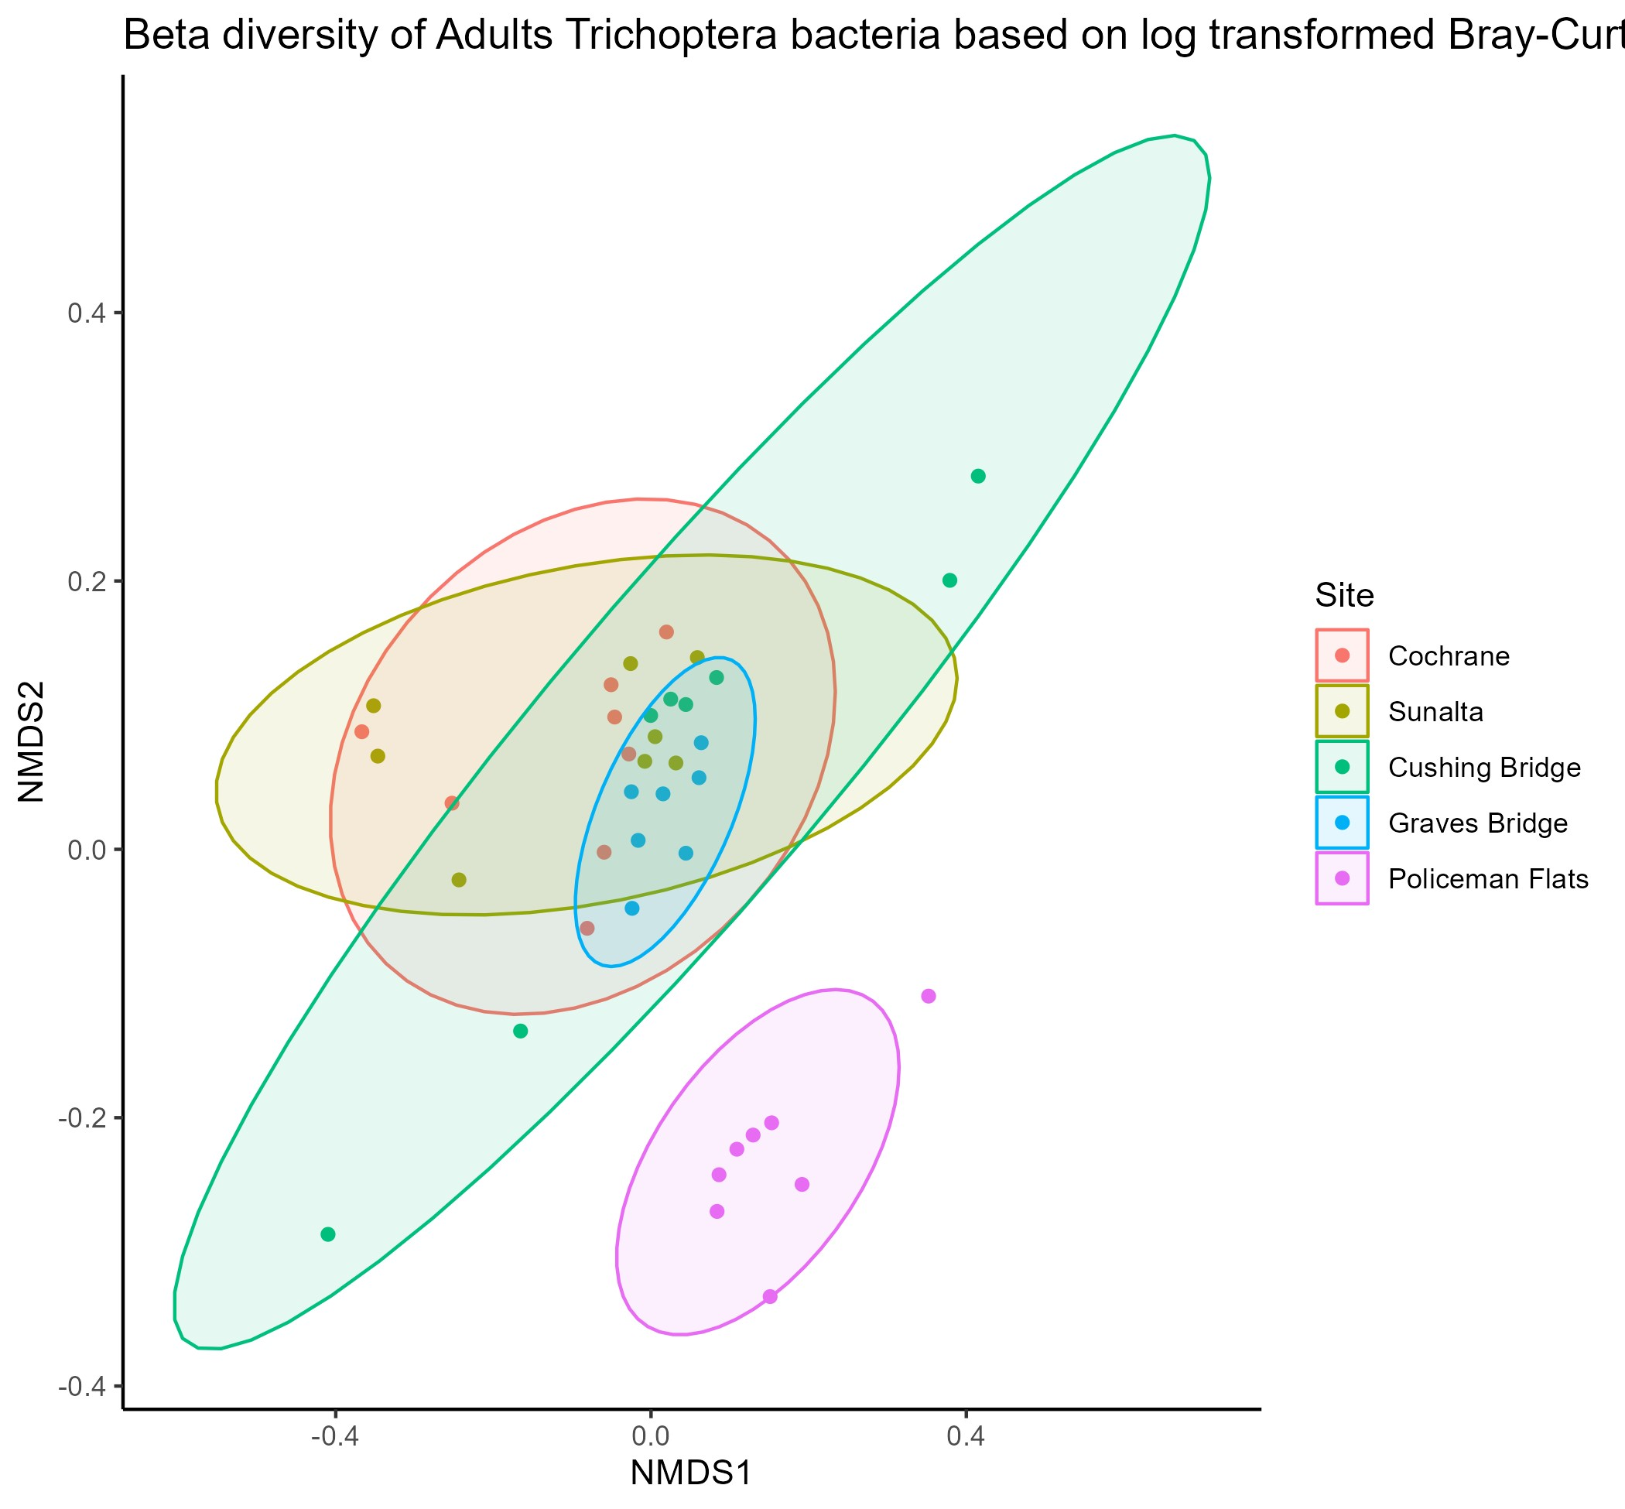

Sunalta - Cushing Bridge, Coch - CushBr, and Coch-Sunalta are not significant, rest are. Beta dispersion is not significant.

Decontaminated analysis:

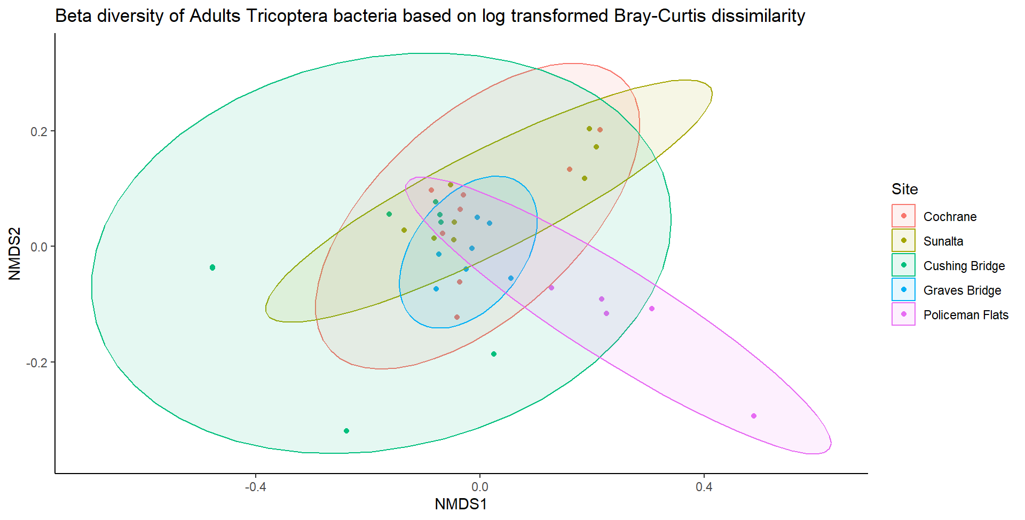

Sunalta - Cushing Bridge, Coch - CushBr, and Coch-Sunalta are not significant, rest are. Beta dispersion is not significant.

## Heptageniidae

Non decontaminated analysis:

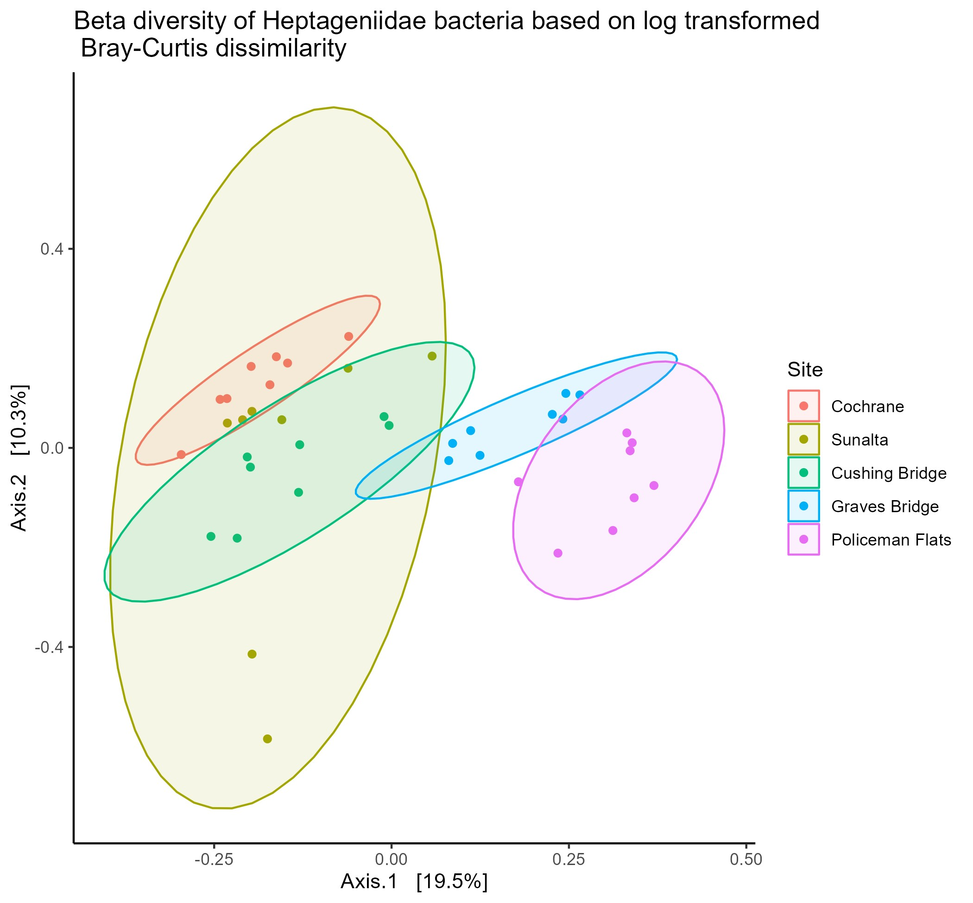

All sites are sig. different from each other. Significant beta dispersion.

Decontaminated analysis:

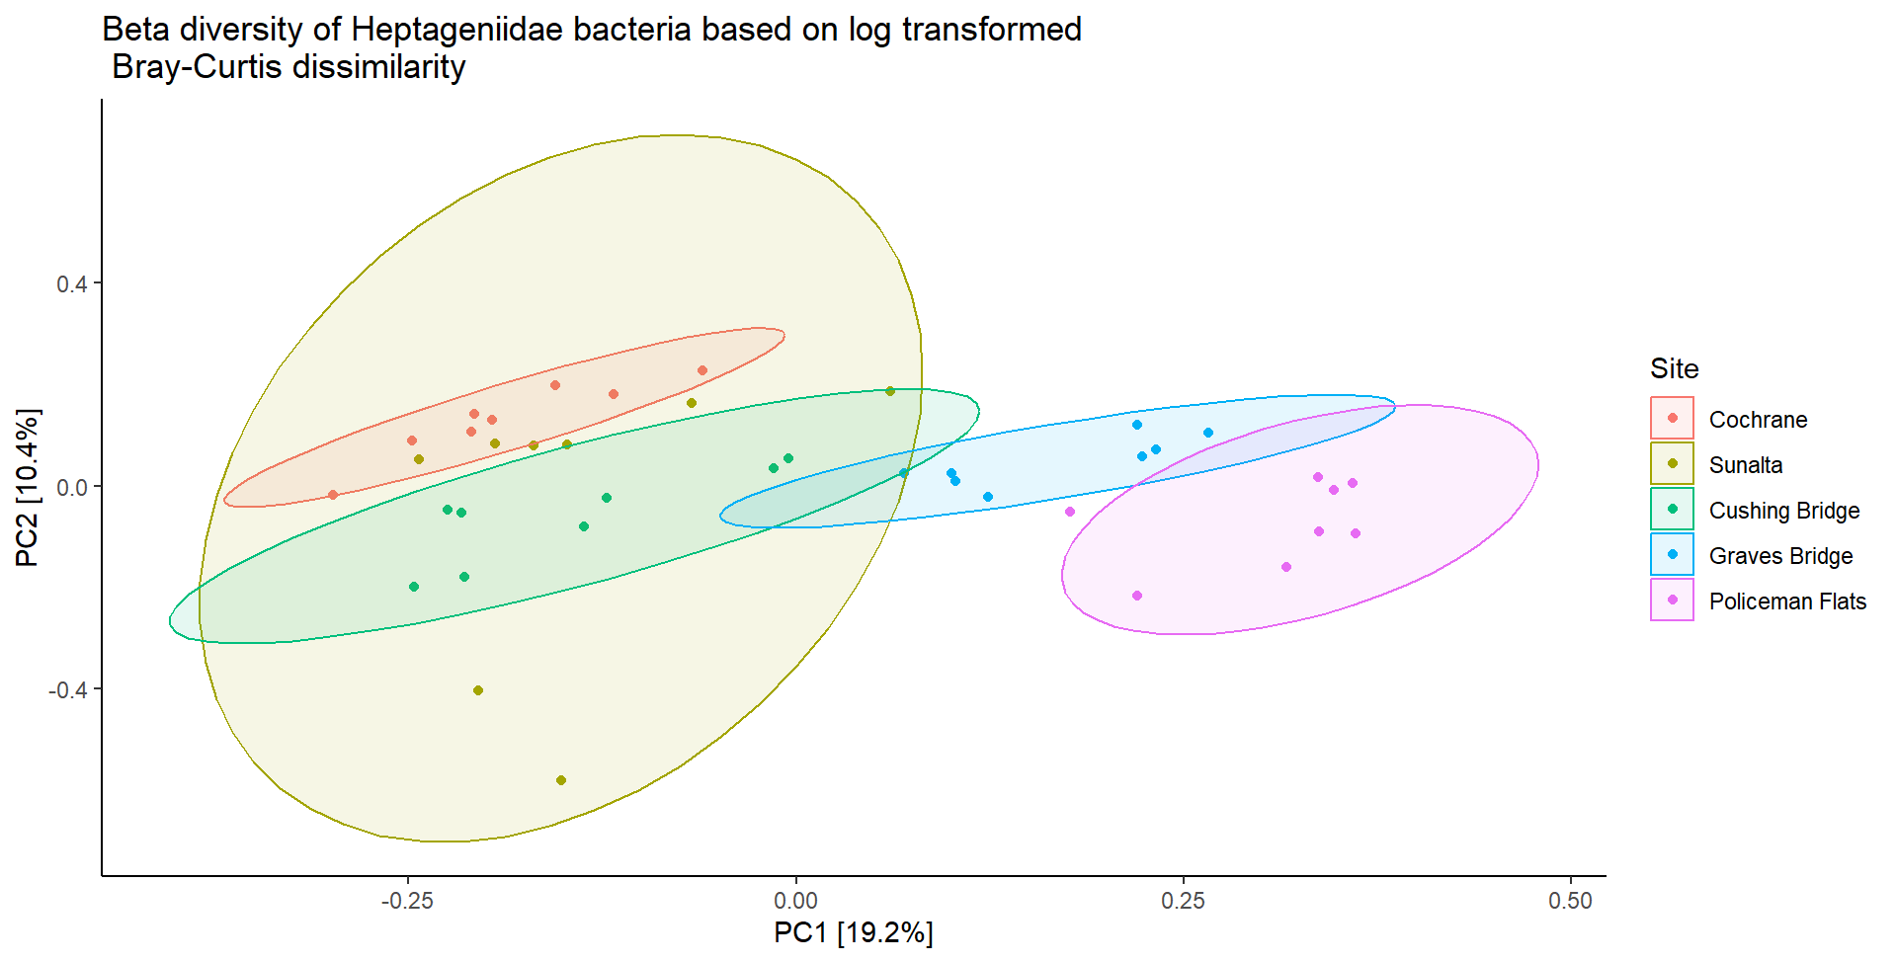

All sites are sig. different from each other. Significant beta dispersion.

## Perlidae

Non decontaminated analysis:

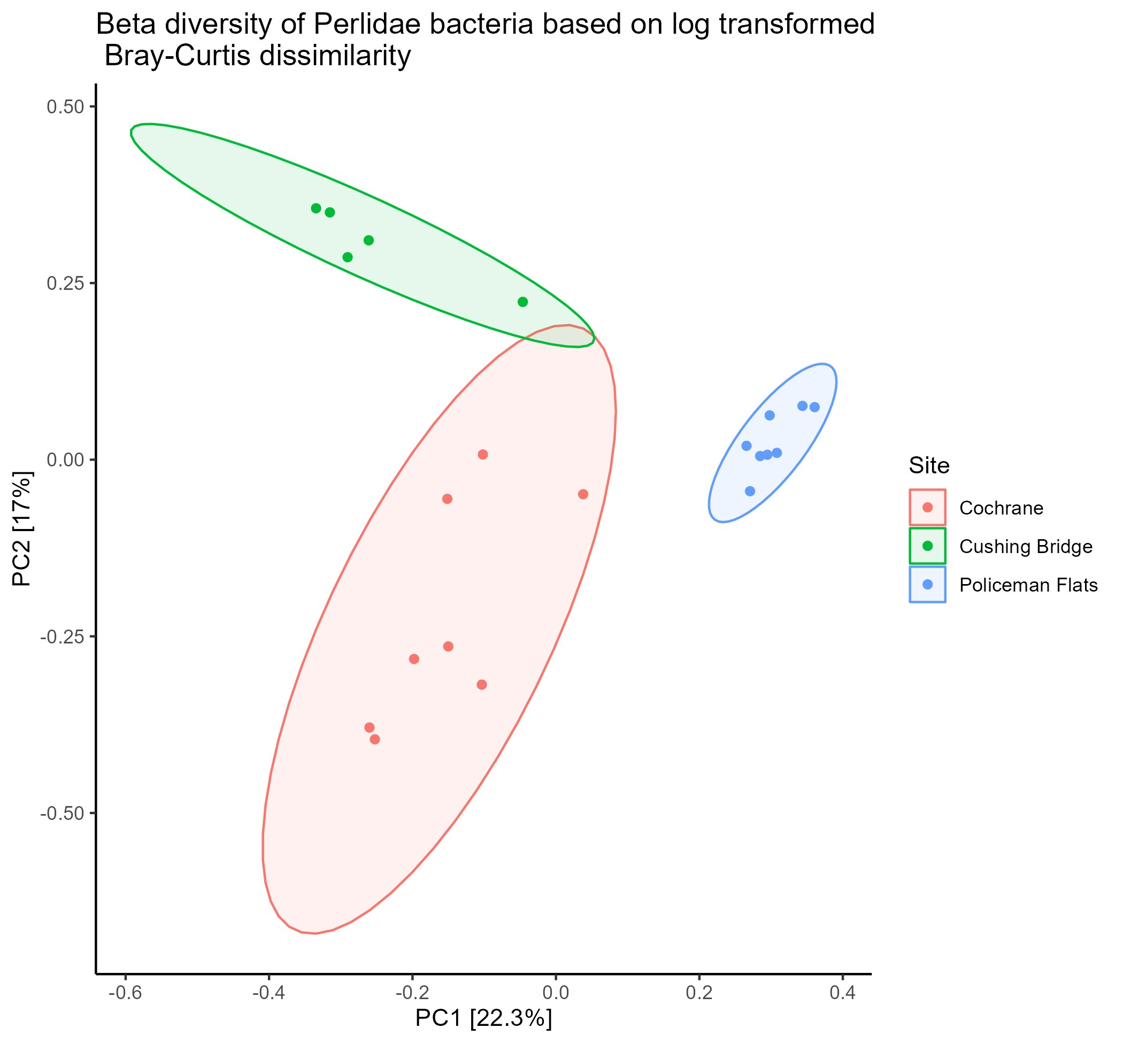

All sites are sig. different from each other. Not significant beta dispersion.

Decontaminated analysis:

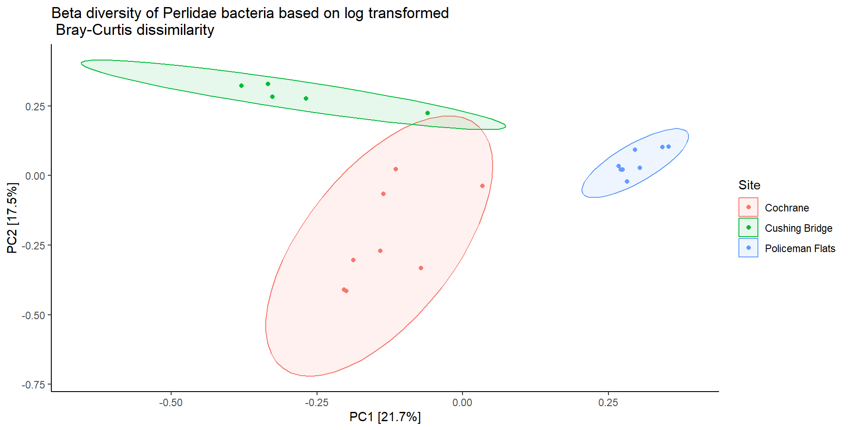

All sites are sig. different from each other. Not significant beta dispersion.

## Chironomidae

Non decontaminated analysis:

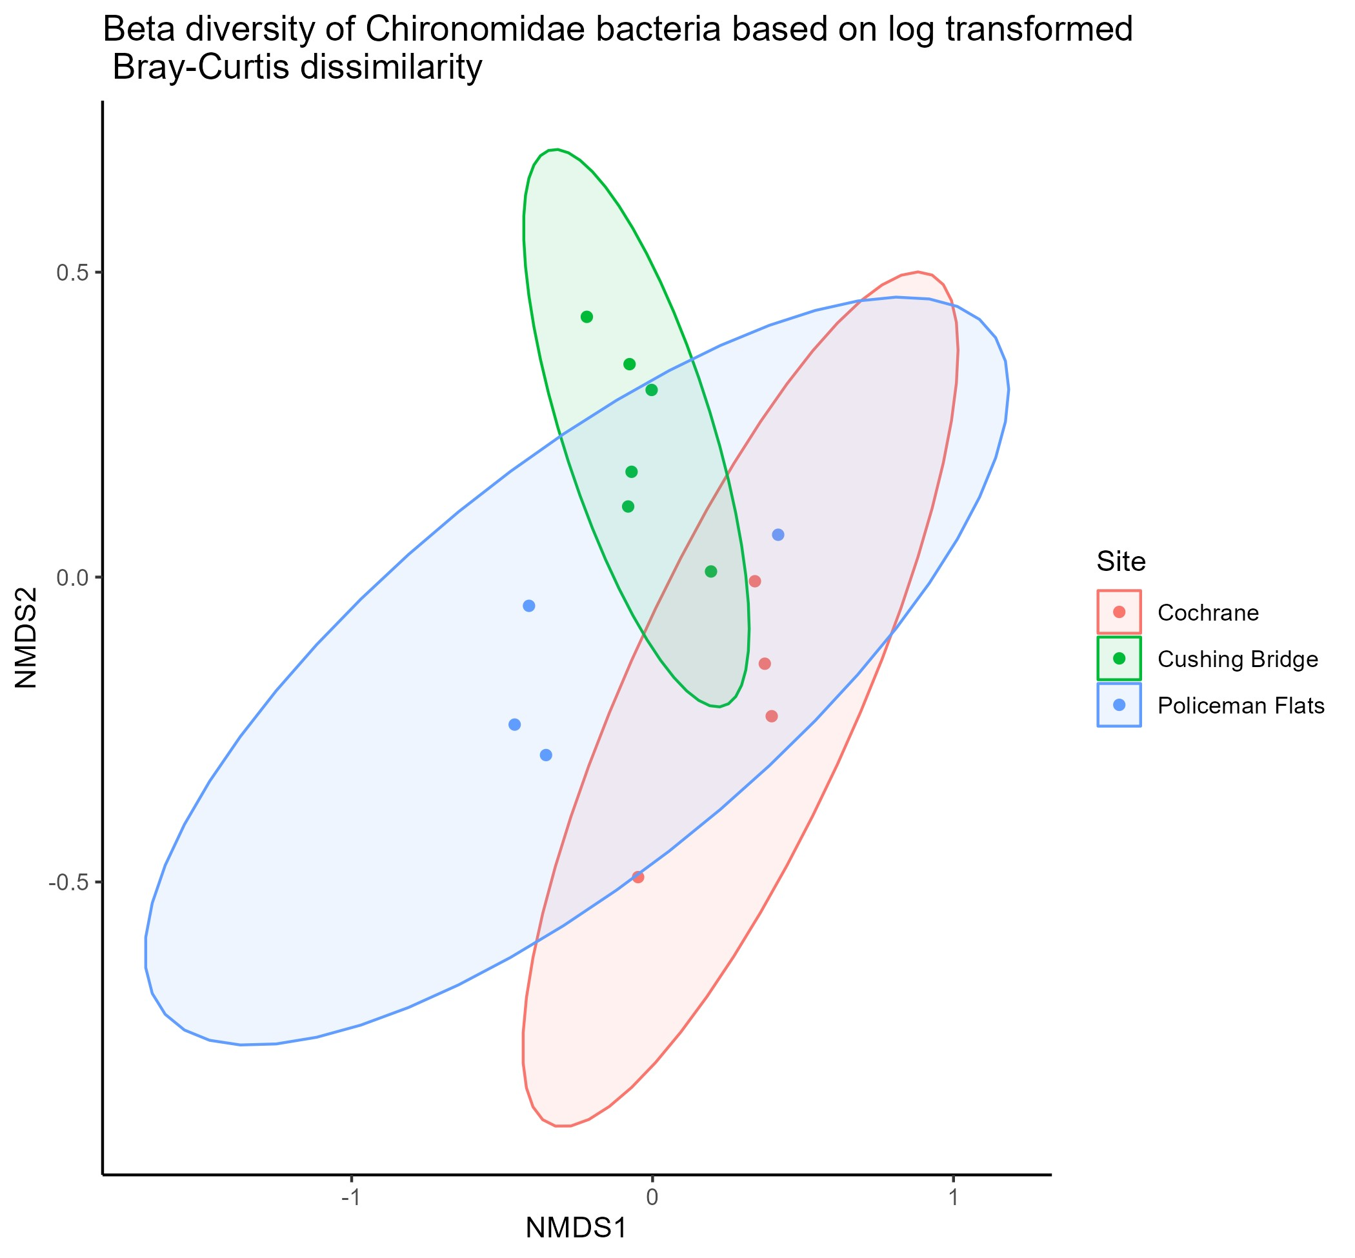

Cushbr – PMF are not sig. different but rest are. No sig. beta dispersion.

Decontaminated analysis:

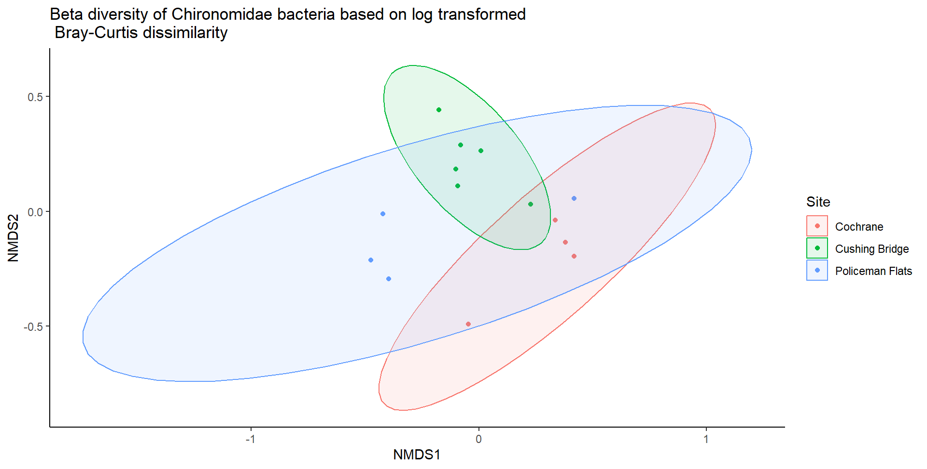

Cushbr – PMF are not sig. different but rest are. No sig. beta dispersion.

## Araneidae

Non decontaminated analysis:



Significant differences between Cochrane and Policeman Flats, Graves Bridge - Policeman Flats, Cushing Bridge - Policeman Flats, Sunalta - Policeman Flats. No sig. beta dispersion.

Decontaminated analysis:

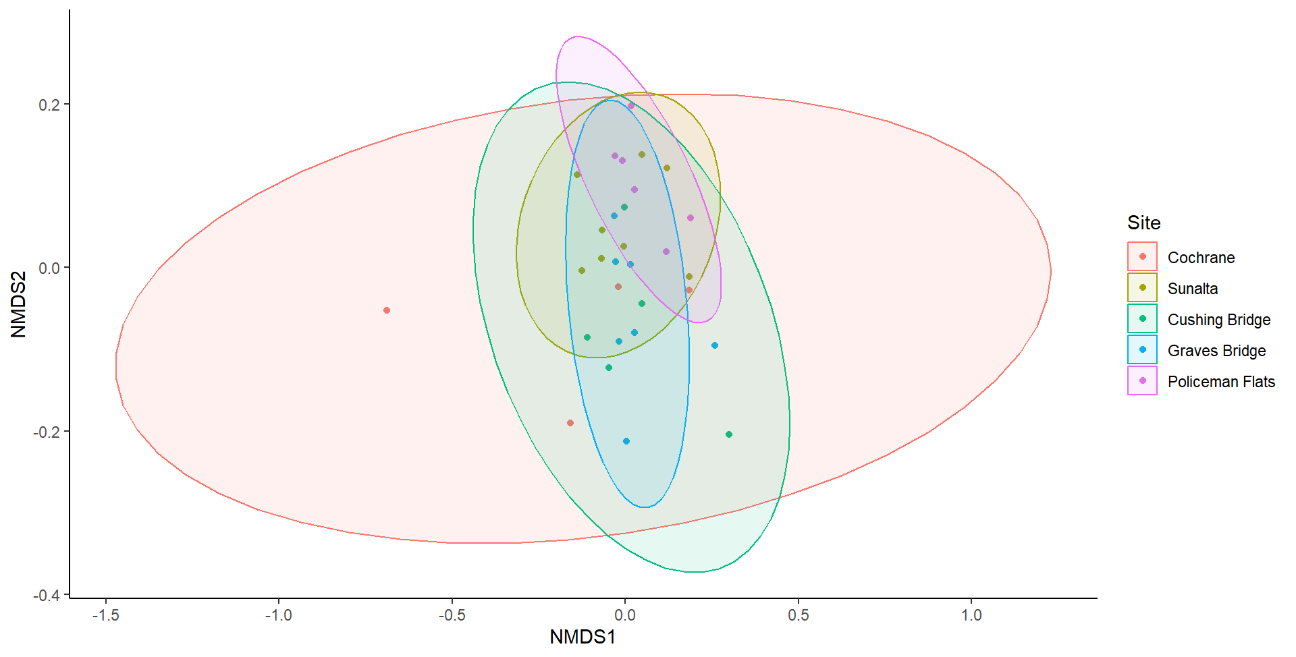

Significant differences between Cochrane and Policeman Flats, Graves Bridge - Policeman Flats, Cushing Bridge - Policeman Flats, Sunalta - Policeman Flats. No sig. beta dispersion.

# Differential Abundance

## ACWA Stream comparisons

BRR2 – PCR1:

Non decontaminated analysis:

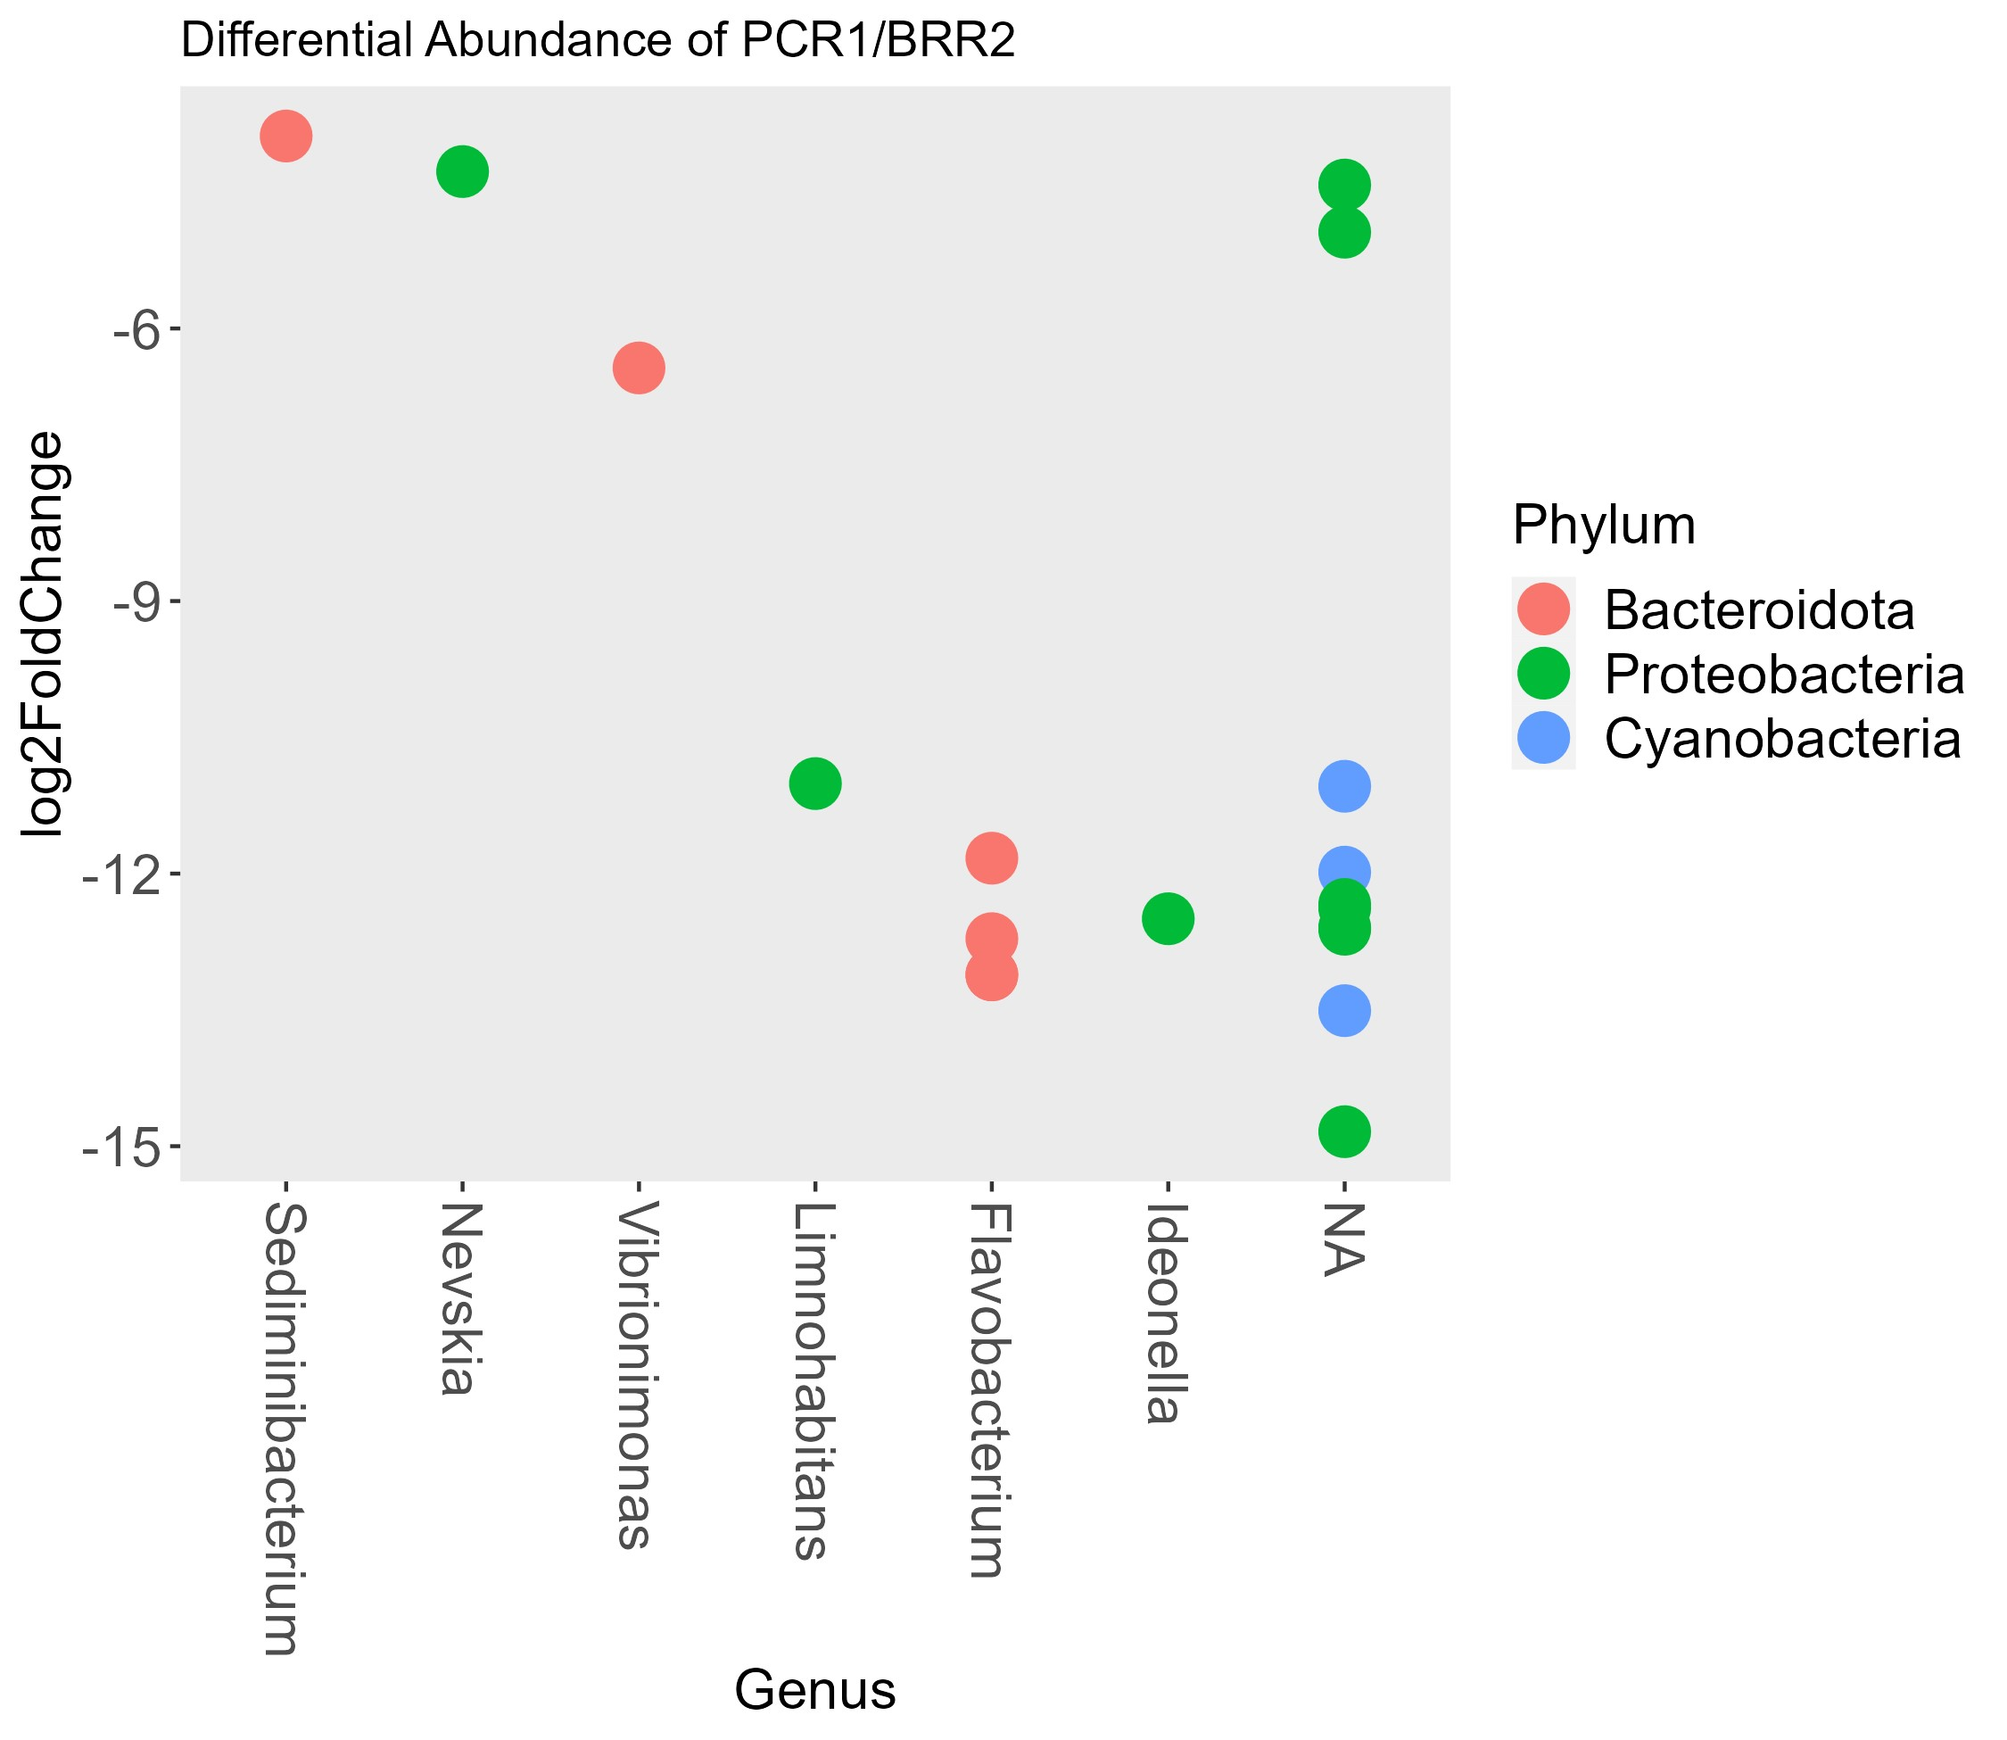

Decontaminated analysis:

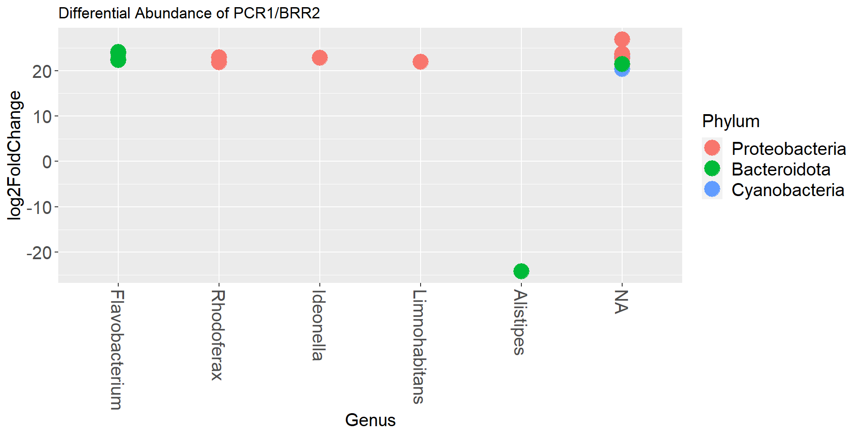

PCR3 – BRR2:

Non decontaminated analysis:

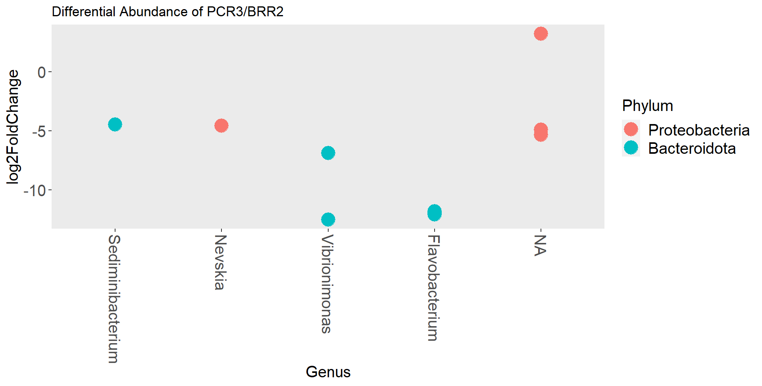

Decontaminated analysis:

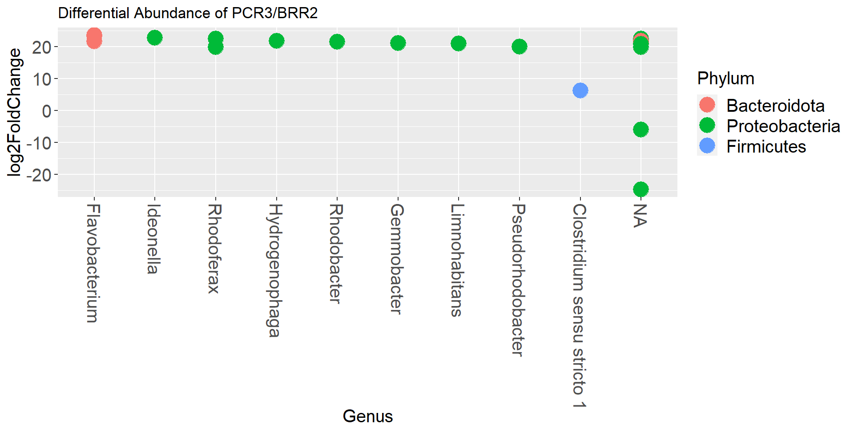

PCR1 – PCR3:

Non decontaminated analysis:

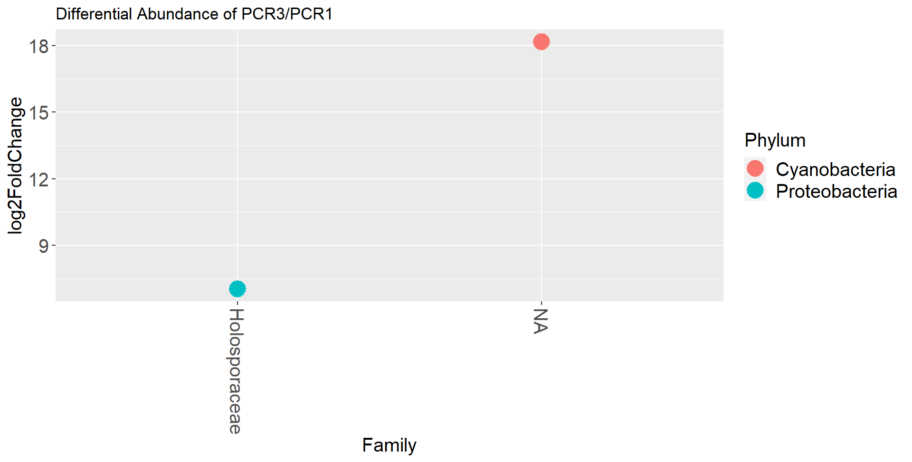

Decontaminated analysis:

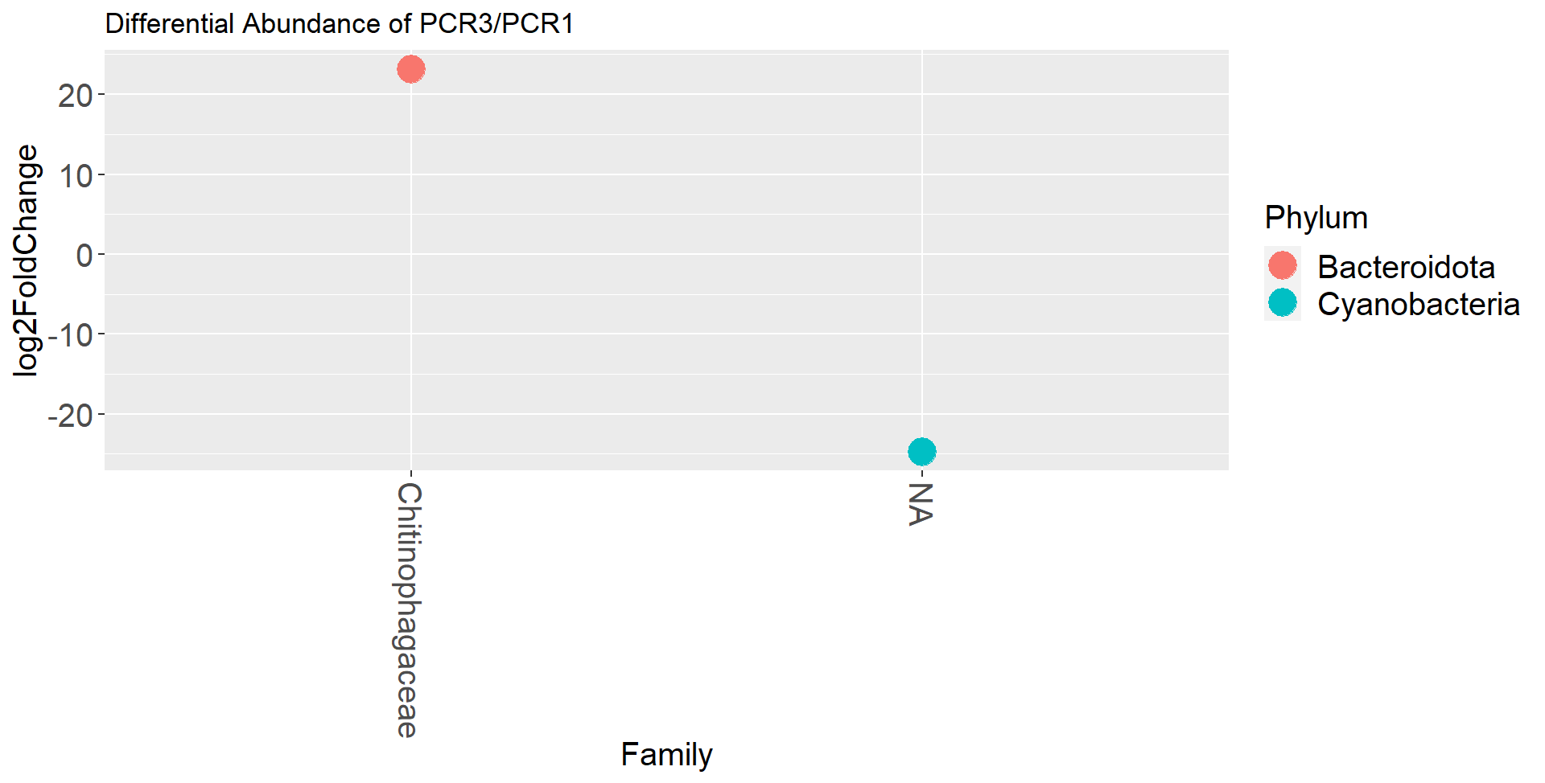

Decontaminating the data completely changes the differentially abundant bacteria in the ACWA streams.